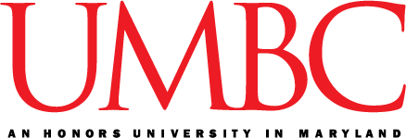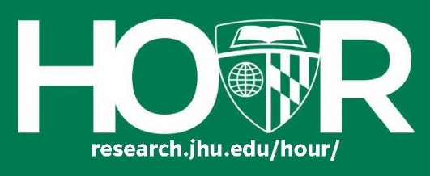

**Second Annual Perspectives on Asia Conference**

The University of Maryland Baltimore County Asian Studies Council of Majors (ASCOM), in collaboration with the Johns Hopkins Office for Undergraduate Research (HOUR), is pleased to announce that the second annual Perspectives on Asia conference will take place on **April 6, 2019**. Undergraduate students conducting research in Asian Studies are encouraged to submit abstracts. Past presenters have drawn from a wide range of topics including political science, history, linguistics, arts, economics, and culture in Asia. We are also excited to announce that HOUR will sponsor a joint JHU-UMBC panel on the Johns Hopkins University campus on **February 21, 2019**.

Interested participants should email an abstract no longer than 250 words to Peri Johnson at [asianstudiescouncil@gmail.com](mailto:asianstudiescouncil@gmail.com) by January 30, 2019. Students should also specify whether they would like to present at Perspectives on Asia, the JHU panel, or both. Emails should include the student’s name, email, phone, school, and project title.Research should have a topical focus, but also relate to larger themes and/or theoretical literature on Asia.

If you are interested in staying updated, please email [asianstudiescouncil@gmail.com](mailto:asianstudiescouncil@gmail.com) and request to be added to our conference mailing list.