
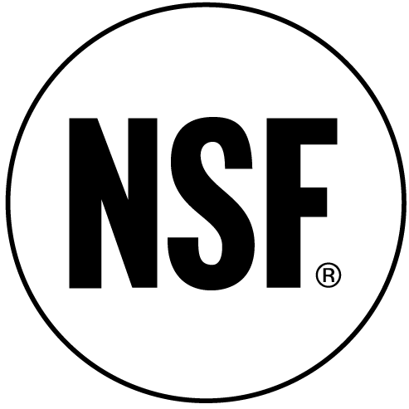
Summer Exploration: STEM Teaching
Co-hosted by the Education Department and Sherman STEM Teacher Scholars Program

The Summer Exploration program is your opportunity to explore a career in teaching. Through enrollment in EDUC 310, you will learn about foundational principles and practice of teaching, classrooms, schools, and communities; additionally, you will teach high school students and will reflect on the experience and on teaching and learning. This permission required course will run from approximately June 25th-July 25th.

This program is FREE to you! The cost of the course and other required activities are fully funded.

If, upon successful completion of the course, you opt to pursue teacher certification, you will be eligible for a scholarship!

Application Deadline: April 20th. Please submit this form along with support documentation to:

Sherman Scholars Program
Care of Rehana Shafi
Academic Services Building, Room 106C
UMBC
1000 Hilltop Circle
Baltimore, MD 21250

Note: To be eligible for this program, you MUST be a U.S. Citizen, Permanent Resident, or National

Selected candidates will be invited to the Sherman Scholar Selection Program to be interviewed.
Please save the date: Friday, April 25th 5:00-8:00p.m.

To complete this form on your screen, place your cursor in the grey boxes and enter your information.

BACKGROUND and CONTACT INFORMATION

Name:

Permanent Address:

Mobile Phone:

UMBC E-mail Address: Alternative E-mail Address:

ACADEMIC INFORMATION

Major: Minor, if applicable:

Overall GPA: GPA in your Major:

SUPPORT DOCUMENTATION

Please also include the following documents:
- Proof of U.S. Citizenship (copy of birth certificate, U.S. Passport, or U.S. permanent resident card)
- Transcript (a copy is acceptable)
- Essay (limit 1 typed page) – Please answer the following:
This summer, in conjunction with your course, you will be working with high school students. Why are you interested in this experience, and what do you hope to gain from it?

I understand that by submitting this application I acknowledge the right of UMBC, Department of Education, and Sherman Scholars Program staff to document (i.e. photographs, video) all summer program activities and to use these materials, including my likeness and testimonials, to further the program’s objectives.

