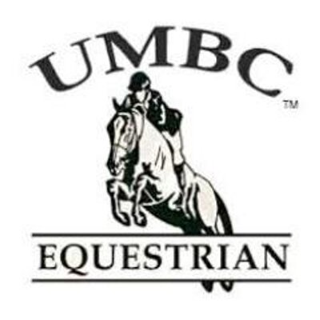 **Club Meeting Agenda -9/9**

1. Introductions
   1. Meet the officers
   2. Meet the new and returning members
      1. Name, year, and riding experience
2. Equestrian 101
   1. $10 per session (4 sessions total)
   2. If interested please sign up and we will plan a time and day.
3. Evaluation rides
   1. Must be done before you can take lessons
   2. Cost is $25
4. Lessons
   1. $25 per lesson
   2. Sherri is available on…
      1. Monday and Thursday evenings
      2. Tuesday and Wednesday mornings
5. Fall 2015 events
   1. FADS (Frederick Area Dressage shows)
      1. Saturday September 19, 2015 @Sugarloaf Equestrian Center
      2. Volunteers needed – Talk to Maggie for more information
   2. Washington International Horse Show
      1. Thursday October 22, 2015 (Barn Night) @ Verizon Center
         1. Video contest
         2. Due by October 14th
      2. Registration due by October 1st
   3. Columbia Classic Grand Prix
      1. September 19,2015 @Marama farm in Clarksville, MD
      2. Lawn seats-$10
      3. Grandstand seats- $15
   4. Show team
      1. First IHSA show- Saturday October 3rd
         1. Club members are welcome to attend and support the show team!

 **Club Meeting Agenda -9/9**

1. Introductions
   1. Meet the officers
   2. Meet the new and returning members
      1. Name, year, and riding experience
2. Equestrian 101
   1. $10 per session (4 sessions total)
   2. If interested please sign up and we will plan a time and day.
3. Evaluation rides
   1. Must be done before you can take lessons
   2. Cost is $25
4. Lessons
   1. $25 per lesson
   2. Sherri is available on…
      1. Monday and Thursday evenings
      2. Tuesday and Wednesday mornings
5. Fall 2015 events
   1. FADS (Frederick Area Dressage shows)
      1. Saturday September 19, 2015 @Sugarloaf Equestrian Center
      2. Volunteers needed – Talk to Maggie for more information
   2. Washington International Horse Show
      1. Thursday October 22, 2015 (Barn Night) @ Verizon Center
         1. Video contest
         2. Due by October 14th
      2. Registration due by October 1st
   3. Columbia Classic Grand Prix
      1. September 19,2015 @Marama farm in Clarksville, MD
      2. Lawn seats-$10
      3. Grandstand seats- $15
   4. Show team
      1. First IHSA show- Saturday October 3rd
         1. Club members are welcome to attend and support the show team!