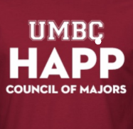

***HAPP COM***

**GBMs on our WebEx teams page once a month!**

**“It’s never too late or too early to get involved”**

|  |  |
| --- | --- |
| * Opportunity to meet and share information | * Discuss mutual interests. |
| * Resource of students seeking information regarding post-graduation goals | * Career networking and guidance with graduate school programs. |
| * Community Outreach Events | * Extra Credit Possibilities |

The Council of Majors welcomes every Health Administration and Policy major to participate.

  @UMBCHAPPCOM

@UMBCHAPPCOM

**Follow us!**

@UMBCHAPPCOM

Visit us @ http://www.umbc.edu/happ/