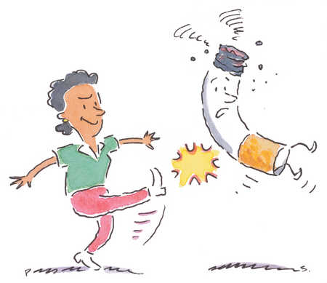
Clean up Your School’s Butt!

When: Friday, April 22, 2011
Where: Check in at UHS/Peer Educators table on Erickson Field
Time: 12:00 pm-1:00 pm
In honor of “Kick Butts Day” and “Earth Day”
University Health Services is partnering with the Students for Environmental Awareness to have a campus wide cigarette butt pick-up hour.
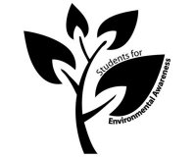
Come join us as we clean up a little bit of our campus and show students how much people are really smoking, and how much we are polluting our campus.
For more information, contact parora@umbc.edu.
