PEER HEALTH EDUCATORS
Contact: cezim1@umbc.edu

Take Action! Get Tested!

Where: Commons Main Street
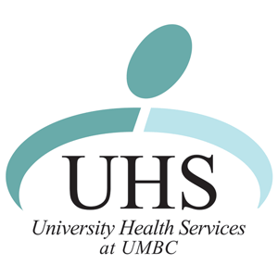

When: Thursday, December 1st
Time: 11am - 2pm


Free Walk-in Confidential HIV Testing at UHS
9am -4pm. No appointment necessary!

Tons of HIV/AIDS Information
Free Trojan Condoms
Free Cupcakes, Candy canes and other treats

