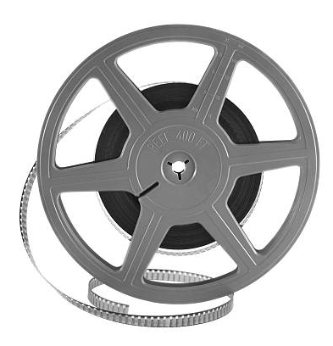
HISTORY IN THE NEWS

Come join us for a conversation led by

Professor Meredith Oyen

on “Walls, Borders, Visas: Today’s Immigration Headlines in Historical Context”


All students welcome.

PIZZA will be served.

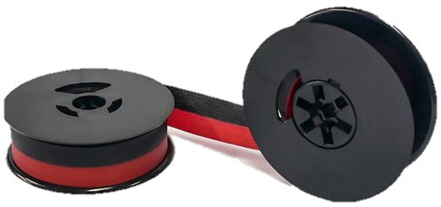


Wednesday, February 27, at noon
in the History Department Classroom
(Fine Arts 533).

Questions?
email Prof. Froide at froide@umbc.edu

