UMBC History Department presents History in the News series


Professor Terry Bouton will lead a discussion with historical perspective on:
Why Do We Have the
Electoral College?
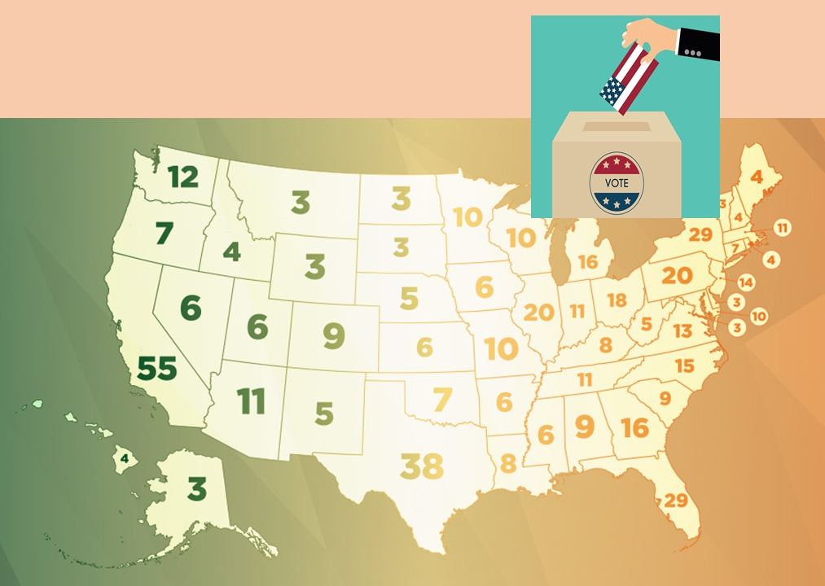
Friday,10/30, 12-1pm
Join Webex meeting
ID: 1209847324
Password: 3Vhckq32
(US) +1 202-860-2110‬ (toll)
Access code: 120 984 732 4

All Students Welcome!
Questions? Please email Carla Ison at ison@umbc.edu

