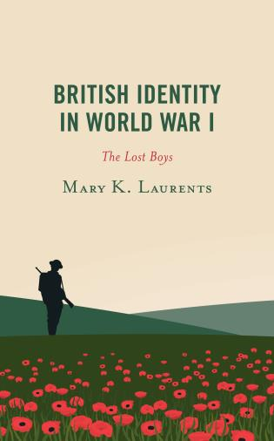
The Department of History and Language, Literacy, and Culture Doctoral Program Present a New Book Conversation with
Dr. Mary K. Laurents
Tues., March 2, 2021
4:30pm
Join Zoom Meeting
https://zoom.us/j/97964245296
Meeting ID: 979 6424 5296
One tap mobile
+13017158592,,97964245296# US (Washington DC)
+13126266799,,97964245296# US (Chicago)
Dial by your location
+1 301 715 8592 US (Washington DC)
+1 312 626 6799 US (Chicago)
+1 929 205 6099 US (New York)
+1 253 215 8782 US (Tacoma)
+1 346 248 7799 US (Houston)
+1 669 900 6833 US (San Jose)
Meeting ID: 979 6424 5296
Find your local number: https://zoom.us/u/ad9kLHtBKK
Please join the History Department and the Language, Literacy & Culture Program in a conversation with Dr. Mary K. Laurents (2018 LLC alumna and a UMBC History adjunct) about her new book, British Identity in World War I: The Lost Boys, published by Rowman & Littlefield. Dr. Dan Ritschel, Associate Professor of History, will facilitate the discussion.

Dr. Laurents utilized her doctoral research for her book which analyzes the development of The Lost Generation narrative following the First World War.

She examines narratives that illustrate the fracture of upper-class identity, including well-known examples of The Lost Generation, such as Robert Graves, Siegfried Sassoon, and Vera Brittain, as well as other less typical cases, George Mallory and JRR Tolkien, to demonstrate the effects of the First World War on British Society, culture, and politics.
Dr. Laurents will also discuss the relevance of the impact of identity fracture to the formation of extremist groups in the present day US.

