NEW ANCIENT STUDIES COURSE IN FALL 2025
ANCS 350-01: ANCIENT ATHENIAN IMPERIALISM
T/Th 1:00-2:15, PAHB 441
Dr. David Rosenbloom
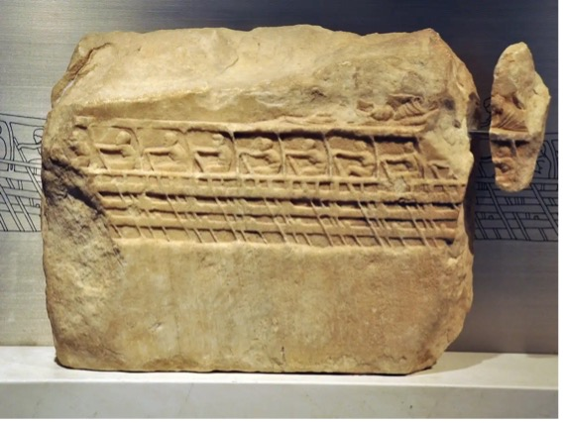
The Lenormant Relief, a rare depiction of rowers on an Athenian trireme (battleship with three banks of oars), Acropolis Museum
The Athenian empire (478/7-405/4 bce) has sometimes taken a back seat to the city’s democracy, economic and social dynamism, monumental buildings and urban amenities, and vibrant culture in historians’ assessments of the city. This class explores the centrality of Athens’ naval imperialism to the city’s political, economic, social, and cultural development during the course of the late-sixth, fifth, and fourth centuries bce. Situating Athenian imperialism in the context of its predecessors and contemporaries in the Near East — Assyria, Lydia and Persia — this course focuses on the origins and evolving tactics and strategies of Athenian imperialism. Topics include the economics and social consequences of the Athenian empire, interconnections and disconnections between empire and democracy, the religious dimensions of Athenian imperialism, and the uses of myth and drama both to legitimize and to question the empire. The class concludes with the fall of the empire after Athens’ defeat in the Peloponnesian War (431-404 bce), the resurgence of Athenian imperialism in the early- to mid-fourth century (377-355 bce), and ancient and modern assessments of the Athenian empire.
ANCS 350-01 has no formal prerequisites and assumes no prior knowledge of the subject; ANCS 201, ANCS 305, and/or ANCS/HIST 453 are recommended preparation.

