
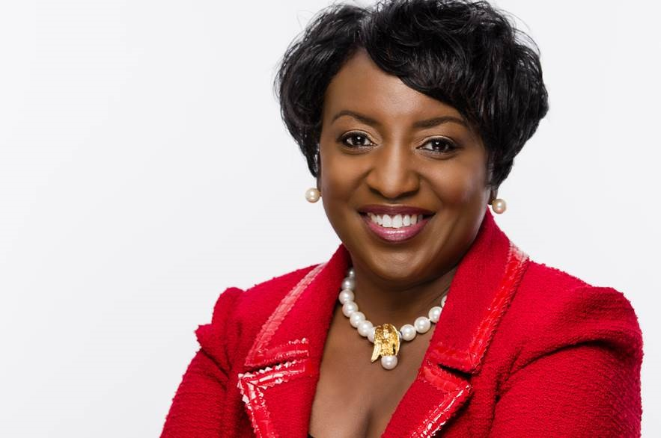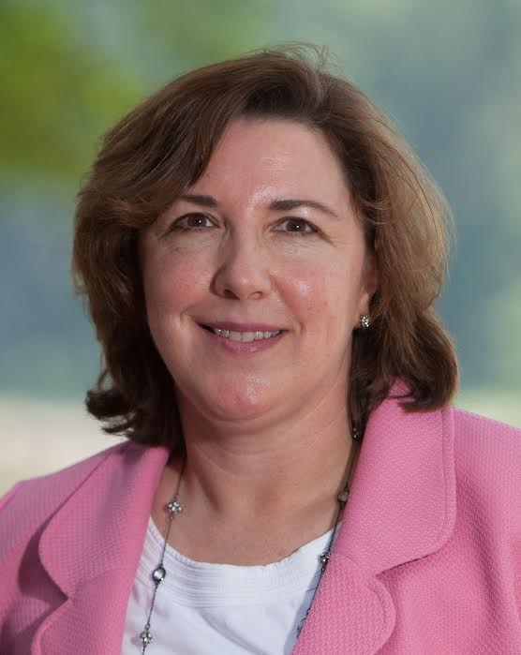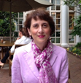
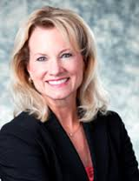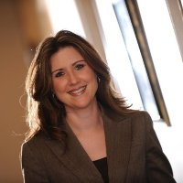

Why should you attend?
- Informal Conversation about different paths to leadership.
- Career advice on designing your career.
- Making hard decisions & overcoming failures
- Technical skills vs Soft skills
- Northrop Grumman Recruiters will be there to meet you.

Agenda:
- Brief Intro
- Panel
- Audience Q &A
- Eating and Networking

WHERE:
University Center Rm 312

DATE
Wednesday –November 18th
5:00-6:30pm

- Belinda Coleman: President/CEO the Coleman Group Inc.
- Brenda Martineau : Organizational Leadership & Management Skill Community Director of NSA
- Deborah Bonanni: Former Chief of Staff of NSA & VP of Intelligent Decisions, Inc.
- Diane Howard: VP of Cyber Operations of Northrop Grumman
- Jennifer R. Walker : President/CEO Resolute Technologies, LLC

Hors d'oeuvres will be served. | Feel free to stop by whenever you can. |No dress code.

