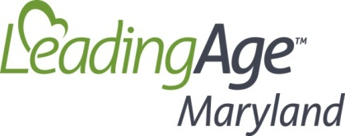

**Student and AIT Event!**

LeadingAge Maryland and ACHCA in cooperation invite you to a Student and AIT experience

Join peers and colleagues to learn and make connections

Education + Connection = Career Success!

**Tuesday, April 25, 2017 from 2:00PM – 5:30PM**

At the Power of Purpose – LeadingAge Maryland Annual Conference

Location: Turf Valley Conference Center, Ellicott City, MD

2:00 pm – Select a session onsite at the LeadingAge Maryland Conference

3:45 pm – Special learning and connection event for Students and AITs

* Why become involved with professional associations?
  + Cecilia Sepp, American College of Health Care Administrators
  + Jill Schumann, LeadingAge Maryland
* Career opportunities in health care and aging and long term services and supports
  + Mary Helen McSweeney-Feld
* Discussion Sessions and a Chance to Make Connections

Refreshments provided

There is no cost to attend, but please RSVP to: [mmcsweeneyfeld@gmail.com](mailto:mmcsweeneyfeld@gmail.com)