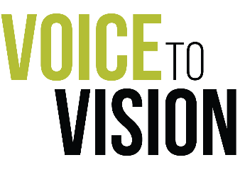
To: All UMBC students, staff & faculty

From: UMBC dining

Subject: Your Campus Dining Survey is here!

Thank you for taking the time to complete this important survey. Your feedback is extremely important to us and will be used to help us reinvent your dining experience here on campus.

Before you start the survey, there are a few important items to note:
- It’s confidential. We do not release individual data to anyone; survey answers are entirely anonymous.
- It’s quick. The survey should take 8 to 10 minutes to complete.
- Take it before it closes. The deadline for completing the survey is October 31st. However, please take it at your earliest convenience.
- Enter to win an iPad! Every UMBC student who submits a screenshot of their completed survey via Instagram DM (@umbcdining) or email (umbcdining1@gmail.com) will be entered for a chance to win a brand-new Apple iPad!

Questions? If you have any questions about the survey process, email raul.cruz@compass-usa.com

On behalf of UMBC Dining, we thank you for taking the time to participate in this very important initiative and sharing your valuable insights!

Click here to take the survey.

