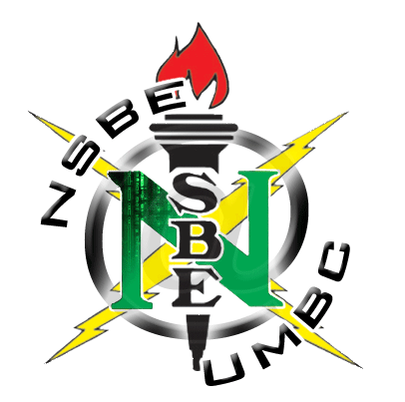
How to Succeed at UMBC
September 27th
Lecture Hall 9
7:30- 9:30pm

A Lecture on Success!
Major-Specified Discussions with Upperclassmen
Networking Opportunities with Peers
Food Provided
All Majors Welcomed!


Cosponsored by NSBE and Phi Beta Sigma

