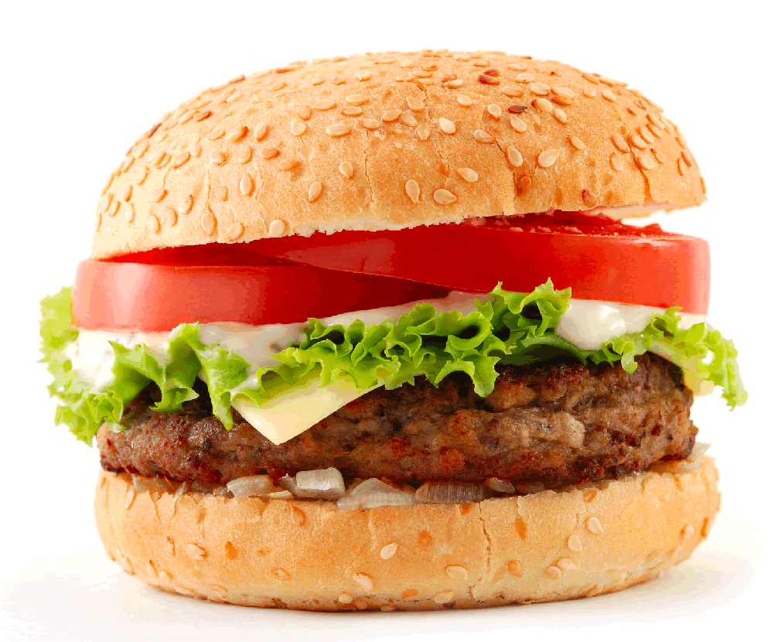
POLITICAL SCIENCE
ALL MAJORS
~ MEETING ~
DATE: WED., SEPT. 9
TIME: 12:00-12:50 PM
WHERE: PUP 206

meet STUDENTS, FACULTY, STAFF
get INFO on COURSES, INTERNSHIPS,
EVENTS, and YOUR POLI SCI DEPT!

FREE FOOD? OF COURSE!
BE THERE !!

