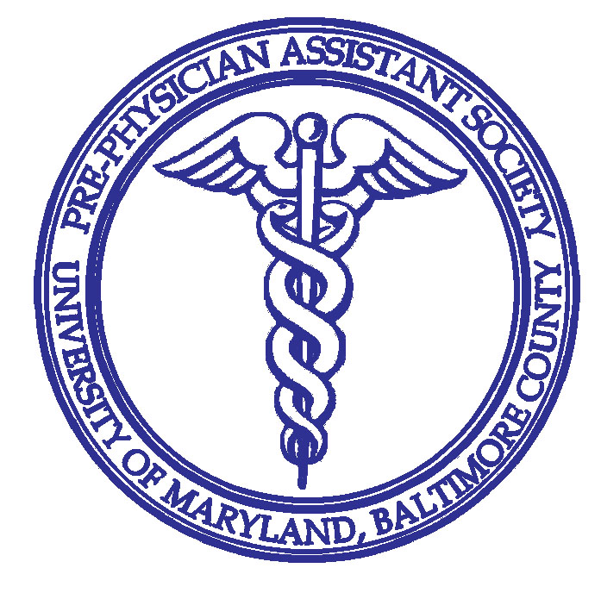

**What is a Physician Assistant (PA)?**

The AAPA acknowledges that that:

* PAs are nationally certified and state-licensed medical professional.1
* PAs can practice medicine on healthcare teams with physicians and other providers.1
* PAs are vital to healthcare. 1
* PAs are experts in general medicine and are vital to healthcare.1
* PAs diagnose, treat and prescribe medicine.1

**What is the Pre-Physician Assistant Society?**

The Pre-Physician Assistant Society is an established UMBC student organization with the purpose of promoting awareness of the Physician Assistant career. We aim to explain the roles and duties of a PA, describe the entry requirements for PA school, and help you along the process of applying for, and working toward a career as a Physician Assistant. Our goal is that students begin thinking about PA school from the start of their college career as we open up opportunities for them to talk to PA school representatives, PAs, and current PA students.

**Where and when are the meetings held?**

Meetings are held bi-weekly on Mondays. The first society meeting is 09/24/18. All meetings will be held on Mondays during free hour, from 12:00-12:50 pm, in the Biological Sciences Building Room 120.

**Pre-PA Meeting Schedule\***

09/24/18 12:00-12:50 Bio 120

10/08/18 12:00-12:50 Bio 120

10/22/18 12:00-12:50 Bio 120

11/05/18 12:00-12:50 Bio 120

11/19/18 12:00-12:50 Bio 120

12/03/18 12:00-12:50 Bio 120

**Pre-PA Event Schedule (with more to come!)**

10/31/18 11:00-2:00 Bakesale

11/28/18 11:00-2:00 Bakesale

TBA TBA Moveable Feast

TBA TBA Guest Speaker

*This schedule is subject to change due to campus closures or inclement weather. Members will be notified in advance of any changes to our schedule.

**Membership requirements consist of at least three meetings and two events. Yes, it’s that easy!**

Fall 2018 UMBC Pre-Physician Assistant Society

**I am interested! Who should I contact?**

We love to hear from you! If you are interested in membership, getting involved or have any questions at all, please do not hesitate to contact any officers listed below!

**Presidents:**

Anna Cook a[cook3@umbc.edu](mailto:Acook3@umbc.edu)

**Vice-President:**

Olivia Orr [oolivia1@umbc.edu](mailto:oolivia1@umbc.edu)

**Secretary:**

Renee Dobrovolsky [rdobro1@umbc.edu](mailto:rdobro1@umbc.edu)

**Treasurer:**

Maheen Ahmed maheena1@umbc.edu

**Public Relations Officers:**

Amaneual Daba adaba1@umbc.edu

Abby Hoy ahoy2@umbc.edu

**Historian:**

Saffa Naeem snaeem1@umbc.edu

**Where can I find out more about getting involved with the Pre-PA Society?**

We send out information in our emails to all members. You can also check out and follow our myUMBC group and our Facebook page. All of these resources give you more details about the very informative and exciting meetings you can attend! They will also help you stay up to date with fundraising events, volunteering opportunities, and other fun society events throughout the semester. Please follow us on the social media below!

**Our society’s myUMBC group page:**

<https://my.umbc.edu/groups/pre-pa>

**Our society’s email:**

UMBC-Pre-PA-group@umbc.edu

**Our society’s Facebook page:**

<https://www.facebook.com/groups/1658594974370899/>

**Our society’s Instagram:**

@umbcprepasociety

*"What is a PA?" - AAPA*. (2017). *AAPA*. Retrieved 10 September 2017, from https://www.aapa.org/what-is-a-pa/