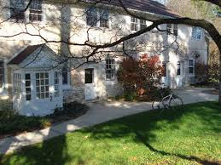

UMBC Faculty/Staff Writers’ Retreat

@ Pendle Hill
Come work on your writing projects in a supportive, relaxing environment with colleagues!

Date: Friday evening, April 5, 2019 through Sunday afternoon, April 7, 2019.
What's Included: 2 nights’ lodging and food (single occupancy - six meals: Friday dinner through Sunday lunch; private use of the Firbank Library space on the campus; coffee and tea service each day).
Where: Pendle Hill, Wallingford PA (https://pendlehill.org/)
Cost: $275 which includes a private room and six meals. A $50 deposit is due by December 1st, 2018 which will be which will be forfeited if you cancel.

If you are interested, please contact Elaine MacDougall (efick1@umbc.edu), English Department, PAHB 425.

