Name | Picture | Quantity
Active Expressions learning devises | 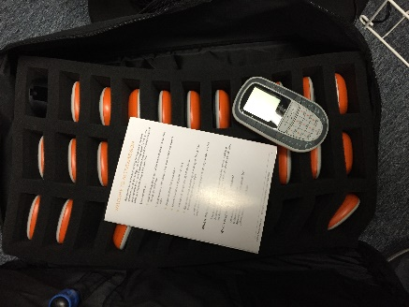 | 1 full zipped bag
Calculators - Electric | 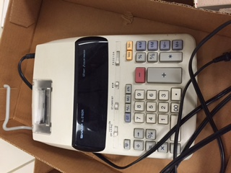 | 1
CD player | 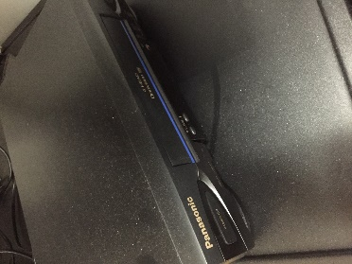 | 1
Envelopes - - Window | 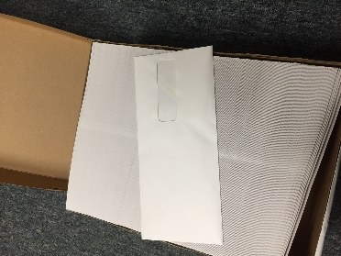 | 2 Boxes
English  Learning  Software  (Name:  Tell me More) | 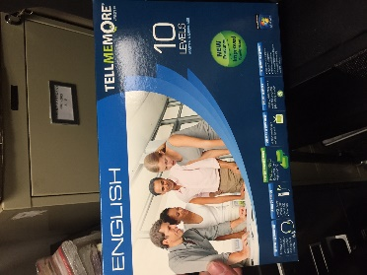 | 24 total
File holder – wire, individual pieces can be used all together | 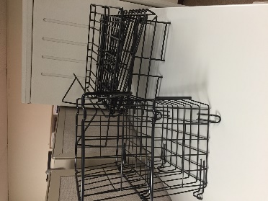 | 2 baskets  3 folder holders  1 magazine holder
Fan | 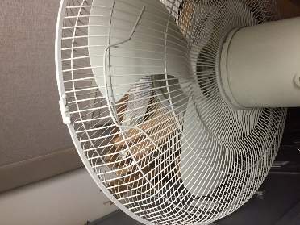 | 1
File Folder  Holder (legal size) | 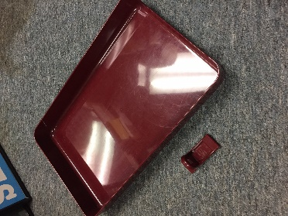 | 8
File folder box - Plastic | 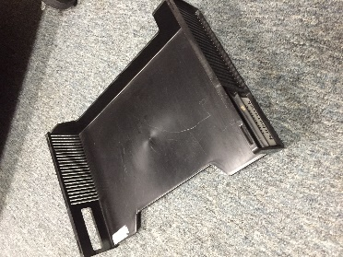 | 8 black
File Folder Holder - Standing | 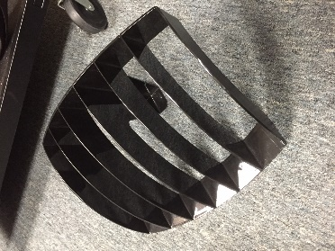 | Big: 1  Small: 4
File folder box - Plastic | 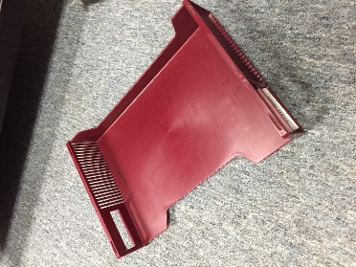 | 9 Red
Hanging File/Paper  Holder | 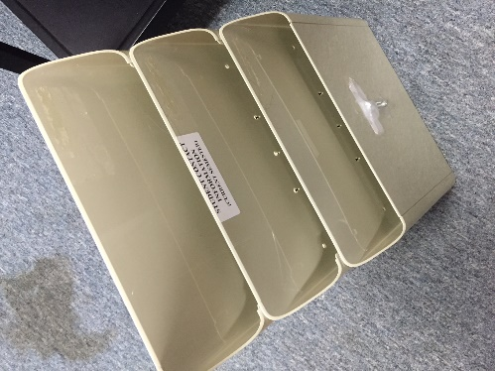 | 1
Lights - Table lights | 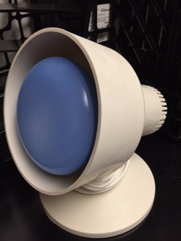 | 3
Microphones | 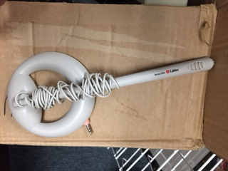 | 5
Notebook – 3 ring binders, spiral | 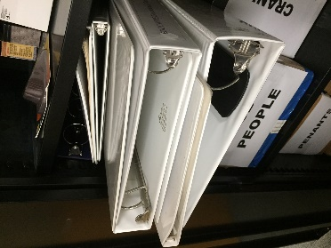 | 5
TV | 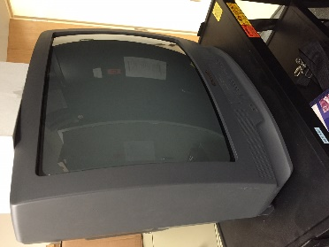 | 2 similar
Tape recorders | 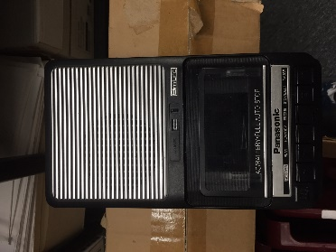 | 21
Tapes | 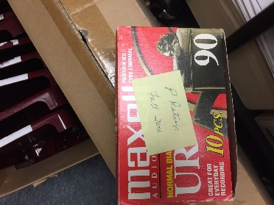 | 2
VHS recorder w/ case | 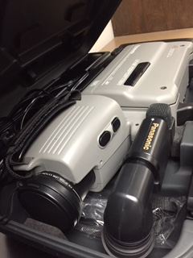 | 1

