Changes in myUMBC Student Administration Reports (Reporting Services Reports)
A1
As part of the REX upgrade there are a few changes to how reports look described below.
Current Look
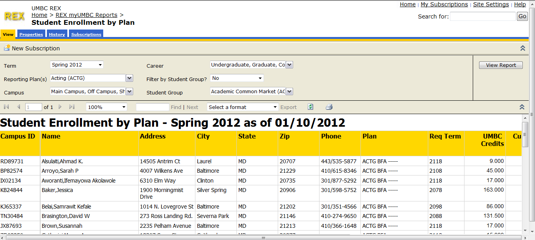
B1

C1

D1

E1

New Look
A2
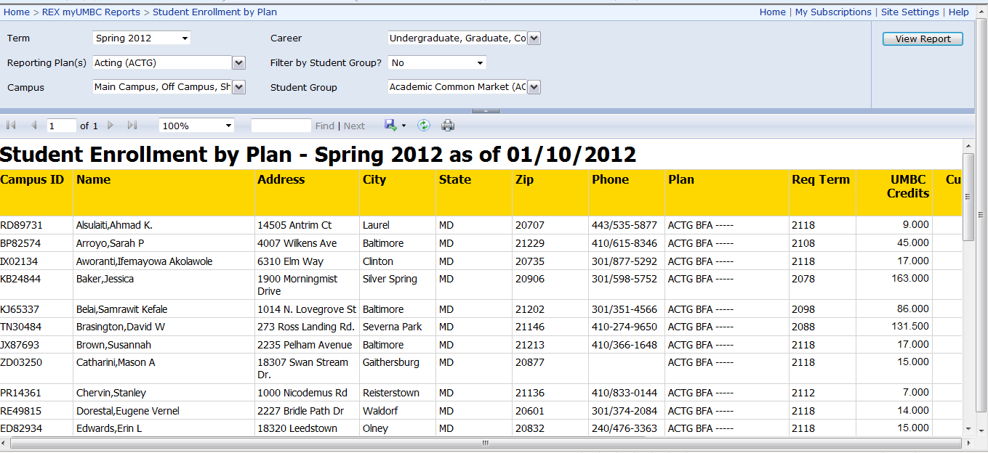
B2
C2
D2
E2

Report Header Section (A)
The Header section (A1 and A2) has become a single line.

Export (B)
Instead of selecting a format and then clicking Export (B1), you now select the format from a single icon (B2).

Refresh (C)
The refresh icon has changed slightly (C1 and C2).

Print (D)
The print icon has changed slightly (D1 and D2).

Hide Parameters (E)
Hiding parameters has changed from the chevron (E1) to a small icon on the separator bar (E2).

