T-REX Financial Reports Fundamentals Training

Participant Manual

Version 7.0
May 2011

Training Agenda

TOPIC | TIME
INTRODUCTION TO T-REX | 5 minutes
PEOPLESOFT TERMINOLOGY | 5 minutes
DATA ACCESS | 5 minutes
T-REX WALK THROUGH & EXERCISE | 45 minutes
RECONCILIATION GUIDANCE | 10 minutes
FUTURE OF T-REX | 5 minutes
Q & A | 5 minutes

Course Overview
Field | Description
Audience | This course is for any users of T-REX for Financial Reports.  These end users can be any staff/faculty on the UMBC campus: department directors, accountants, business service specialists, faculty in any department, administrative assistants, divisional coordinators etc.
Prerequisites | A basic knowledge of computers is required. You need to be familiar with using a web-browser to browse web-pages. Knowledge of the PeopleSoft Financials would be helpful.
What is covered in this Class? | The purpose of this course is to provide basic T-REX knowledge, specifically to navigate to and in the standard financial reports provided via myUMBC.  After completing this course, you will be able to:  - Access T-REX financial reports.  - Run T-REX financial reports for varying departments.  - Drill to detail in the T-REX financial reports.  - Save, print, export to Excel and email reports  Hands-on practice will be combined along with the demonstration of different activities performed in T-REX.
Length | The length of this course is approximately 1.0 – 1.5 hours.

Introduction

T-REX (Shorthand for Transactional REX; REX is the UMBC reporting tool for PeopleSoft Student Administration (SA) data) is a web-based data warehouse application that is used to store and process UMBC's data resources. It provides a large library of reports to assist in analysis and decision support. T-REX provides accurate, timely information ensuring sound business recommendations and decisions. This will ultimately enable us to serve all our clients (internal and external) better.

Learning Objectives

The purpose of this course is to provide basic T-REX for Financial Reports knowledge, along with information and tools, to effectively navigate and run reports in T-REX.

After completing this course, you will be able to:

- Access T-REX financial reports.
- Run T-REX financial reports for varying departments.
- Drill to detail in the T-REX financial reports.
- Save, print, export to Excel and email reports

Module 1: What is T-REX?

The Data Warehouse

- T-REX is a Data Warehouse
- Library of delivered higher education reports
- Powerful analytic capability to support decision making and management information needs
- Used for basic financial reporting, performance measurement, analysis and decision making for staff and faculty.
- Variety of reports such as grids, charts/graphs and time series (point-in-time, year-to-year)

Types of Financial Reports

- Basic Departmental Report –Summary

Navigation: myUMBC >> Topics >> Financial Services & Accounting >> Financial Administrative Reports >> Department Report (Summary)

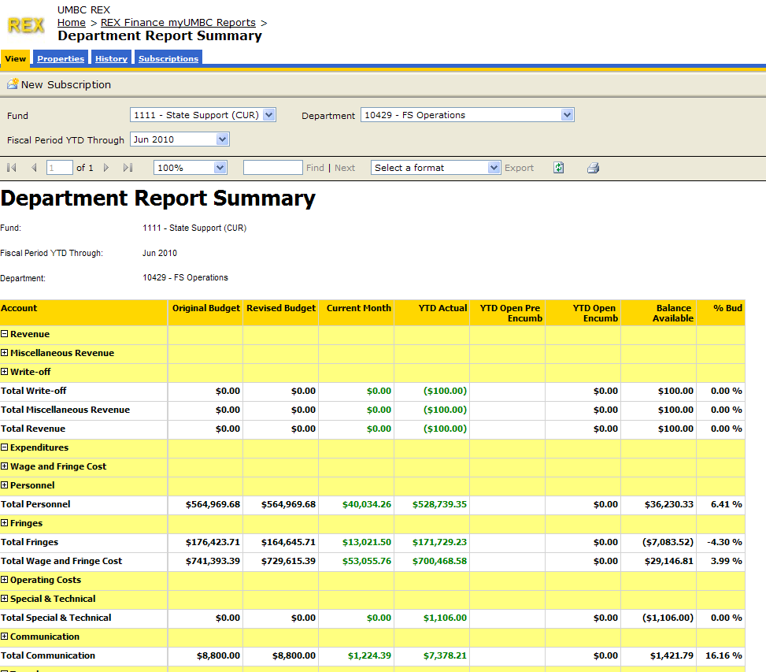

- Basic Departmental Report – Detail

Navigation: myUMBC >> Topics >> Financial Services & Accounting >> Financial Administrative Reports >> Department Report (Summary) - Click (Drill) on any number in the Summary Report that is green to drill to detail.

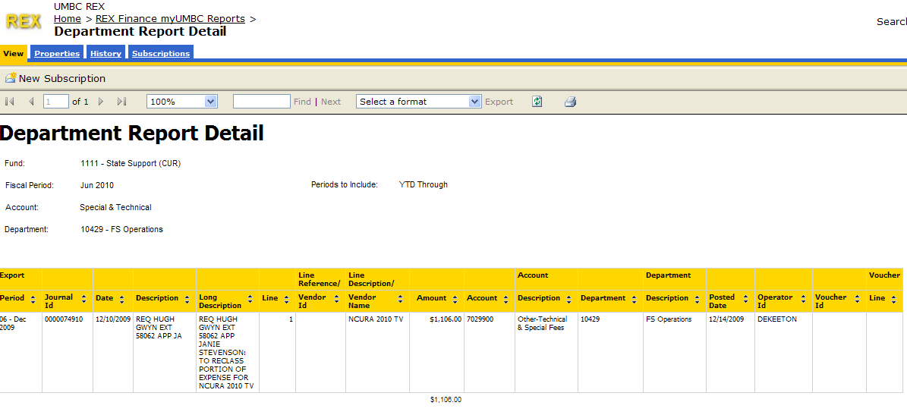

Module 2: T-REX/PeopleSoft Terminology

Financial Reporting Element* | Characteristics | UMBC model
Fund | - Distinct category of financial activity – required by GASB | 1111 – State supported fund  1112 – Auxiliary Fund  1113 – Self Support fund/DRIF & Revolving  1114 – Cost Share  1253 – Contracts & Grants  1263 – Financial Aid
Account | - Business transaction category  - Includes: Revenue, Expense, Assets, Liabilities, Net Assets | Numerous – General Rule  4XXXXXX = Revenue  5XXXXX = Allocations & Transfers (Limited Use)  6XXXXXX, 7XXXXXX, 8XXXXXX = Expense
Department | - An organizational unit responsible for business transactions. The unit will have employees and usually has a budget | Numerous  Reports can be generated by department number (in numerical order by drop down list)  OR  Department name (Typing first letter of alphabet will sort all departments beginning with that letter)
Fiscal Period | - Denotes the period of the fiscal year through which the data is being requested | Month and Year (e.g. – June 2010).  Data will include all fiscal year transactions through and including the period chosen.

Module 3: T-REX Basics

The purpose of this module is to introduce basic T-REX concepts, which will prepare you for using the system.

At the end of this module, you will be able to:

- Access T-REX financial reports.
- Run T-REX financial reports for varying departments.
- Drill to detail in the T-REX financial reports.
- Save, print, export to Excel and email reports

Before We Begin

- For all of the functionality of T-REX to work properly, you need to be using Microsoft Internet Explorer (IE).
- Turn off pop-up blocking in your browser.
  - Click the drop down arrow next to “Tools” on your IE browser toolbar. 
  - Click “Pop-up Blocker”
  - Select “Turn off Pop-up Blocker” 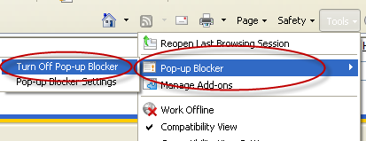

- To access T-REX from off campus, you must be on the UMBC VPN. (Instructions for logging on in Appendix II)

Accessing T-REX

You access T-REX through myUMBC. Once logged on, you are ready to access T-REX.

- Go to http://www.my.umbc.edu

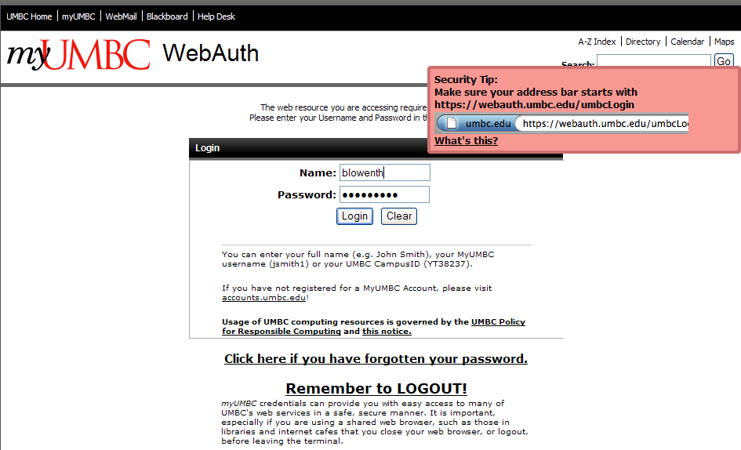

- Enter your Username and Password and click the ‘Login’ button

- The myUMBC home page displays.

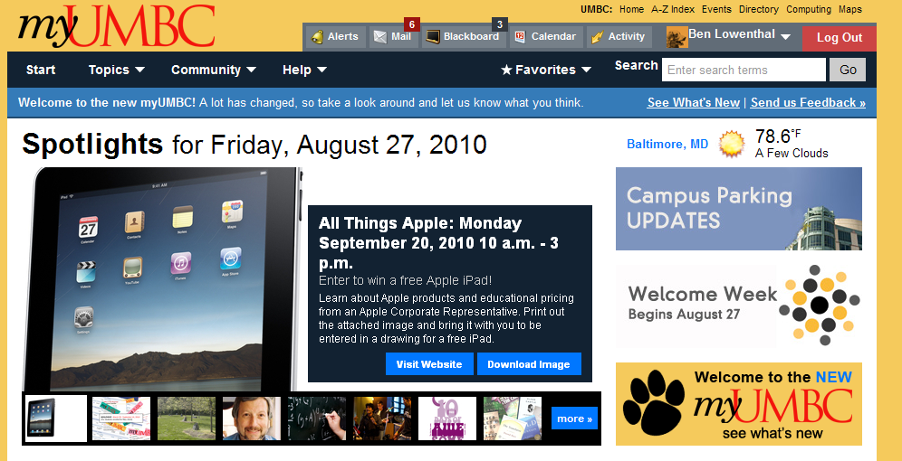

- Click on the ‘Topics’ link and then ‘Financial Services & Accounting link at the top left of the page.

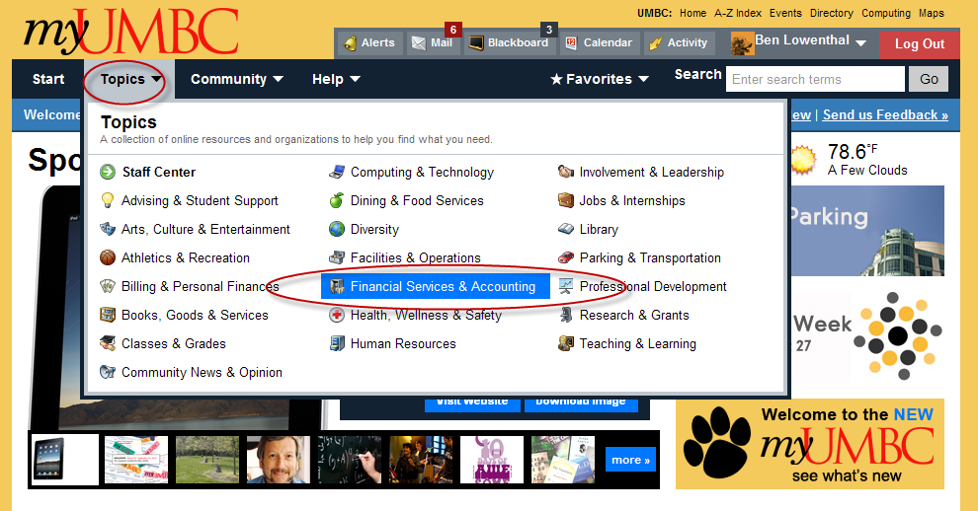

- The Financial Services & Accounting page displays.

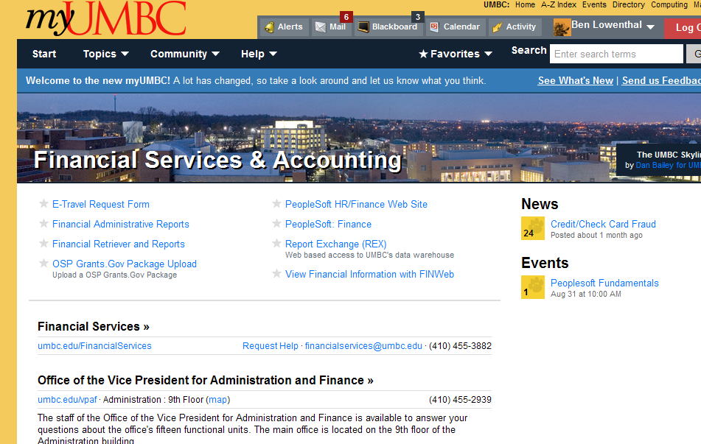

- Click on the ‘Financial Administrative Reports’ link towards the top left of the page.

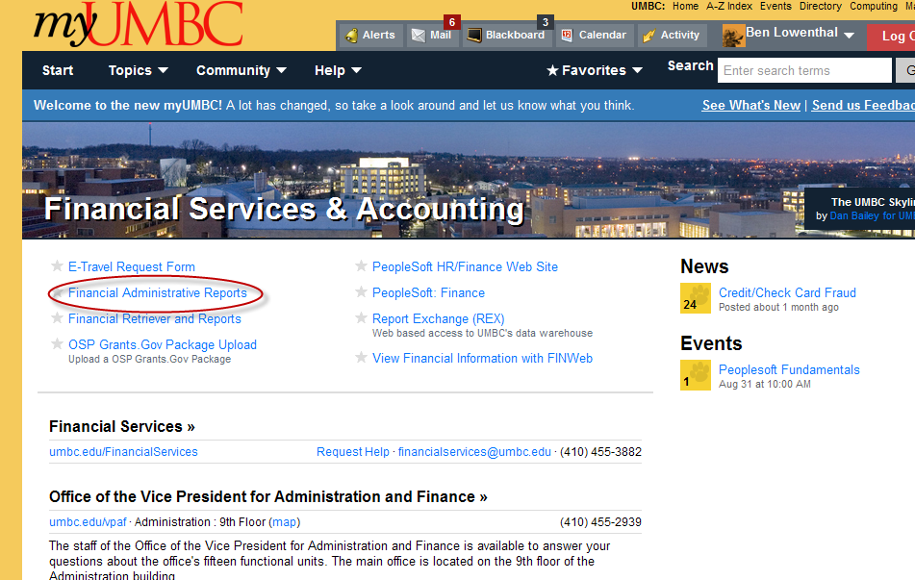
- Click on the gray star to the left in order to add this menu item to your myUMBC favorites. (optional)

- The Financial Management Reports (T-REX) page appears. Click on the Department Report Summary link.

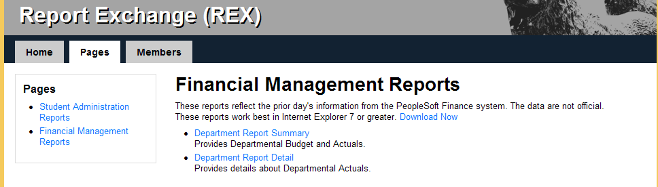

- The pop-up requesting your T-REX/iStrategy password appears. Enter your User Name (always type “ad\” first and then “username” (no spaces) and Password as shown.)

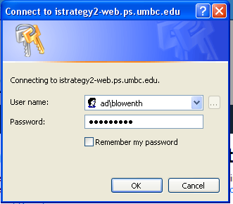

- The Department Report home page displays.

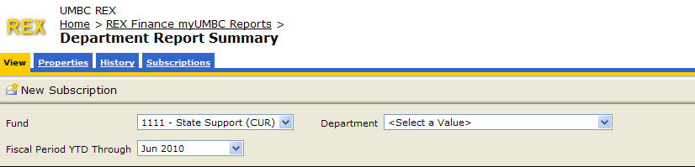

- Select a Fund from the drop down list (Default is 1111 – State supported fund). Funds other than Auxiliary will become available at a later date.

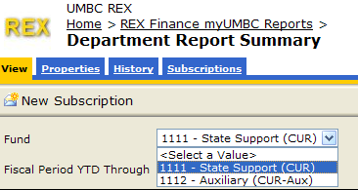

- Select a Fiscal Period from the drop down list.
NOTE: Data will include all fiscal year transactions through and including the period chosen.

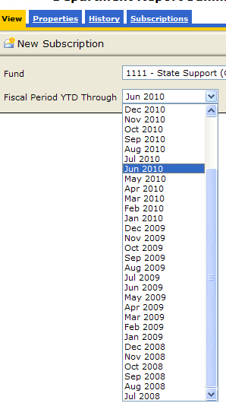

- Enter a known Department number in the Department field.

OR select from the Dropdown list in the ‘Department’ field by clicking on the .

NOTE: Reports can be generated by:

- Department number (in numerical order by drop down list). (Typing numbers will enable you to jump directly to the department(s) with the numbers typed in the list.) To type additional numbers, be sure to type quickly!)

OR

- Roll-up department name (Typing first letter of alphabet will sort all roll-up departments beginning with that letter. To type additional letters, be sure to type quickly!)

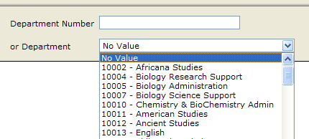

- Once all field parameters are chosen click on the ‘View Report’ button on the top right of the page.

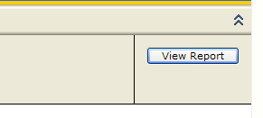
- The Department Summary report displays.

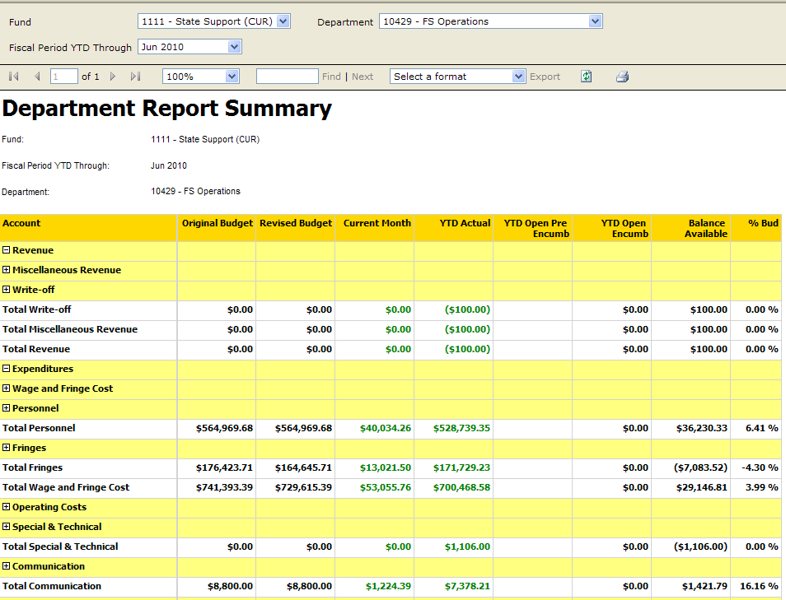

To increase screen space and thus the amount of data showing on screen you can:
- Press F11 (function key at top of keyboard) to eliminate the IE toolbars
- Use the 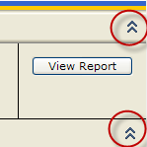buttons in iStrategy to eliminate headers appearing above each of the double arrows.

Expanding and Drilling (Departmental Detail Reports)

To access more detail directly from your Summary Report, you can drill (by clicking on the link from any green number) or expand a measure (by clicking on the plus sign next to any row header)
.
- To expand to more detail (for example) on Operating Expenses, click on the plus sign to the left of the header row (Communication, Travel, Contractual Services, or Supplies as highlighted below.
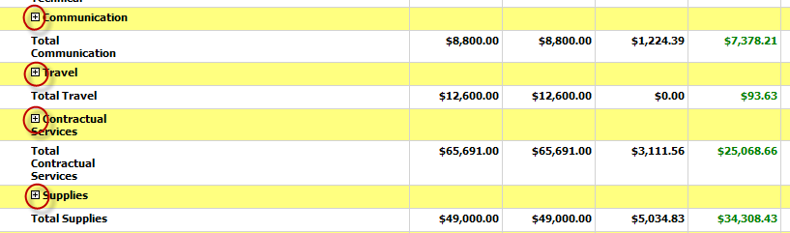

- The row will expand to more detail with each click of a plus button. When the lowest level of detail is displayed, the plus sign will become a minus sign as in the Communication example below:

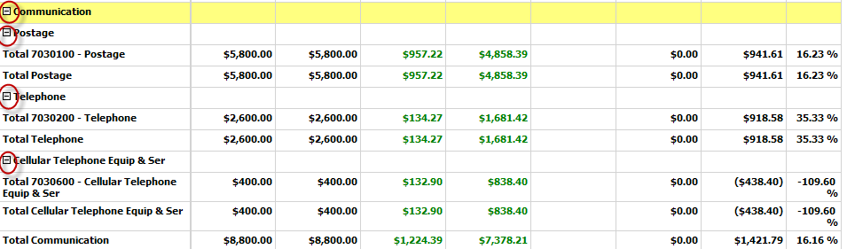

- To drill to detailed journal entries and vouchers on any particular line item, simply click on any green number link. A new report will be generated with the requested detail, as follows:

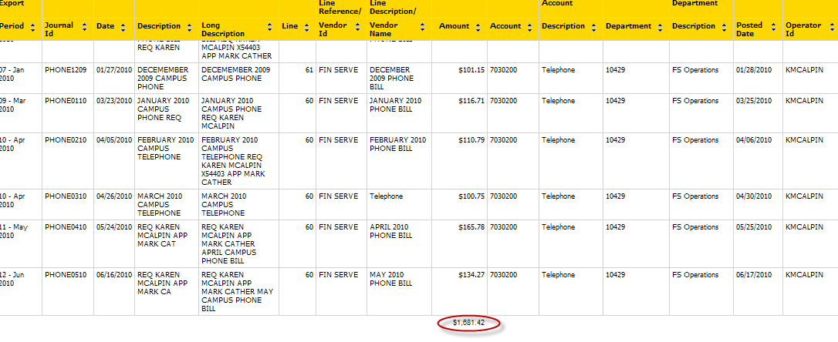

The report will default to date order with a total amount calculated at the end of the report matching the number from which you drilled.

- To change the sort order key, use the blue arrow buttons to the right of the column headers.

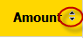

- A single click will sort by this header in ascending order. A second click will switch the sort order to descending. The arrows will indicate sort order once clicked. The screen shot below is sorted on amount in ascending order as indicated by the highlighted arrow.
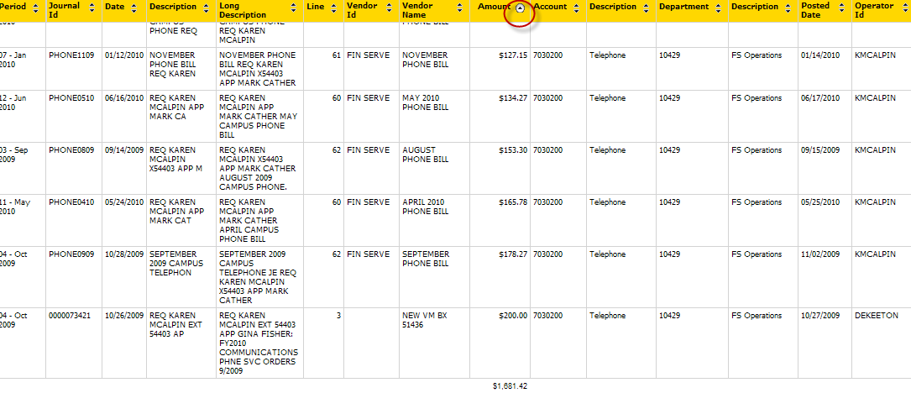

- ADDITIONAL DRILL TO VOUCHER & P-CARD TRANSACTION DETAIL (AVAILABLE 5/18/11)
  - Transactions in the detail that have additional details available will appear as green numbers in the detail report. These will include:
    - Transactions tied to a voucher (e.g. Transaction tied to a Purchase Order, a petty cash transaction)
    - P-card transactions (indicated by BANK OF AMERICA as the vendor)
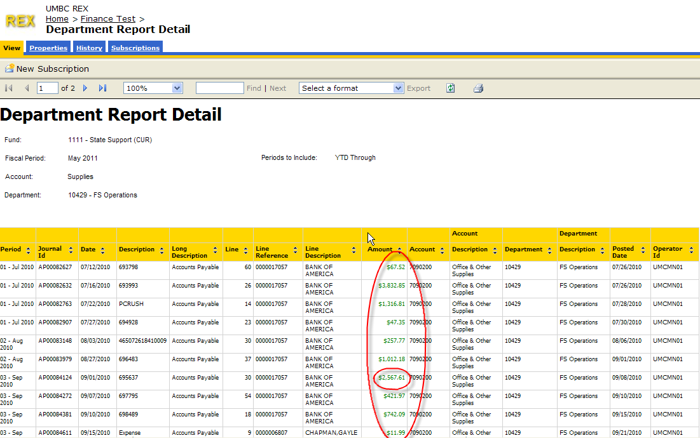

  - In order to drill to the additional details, simply click on the green number link. A new report (Department Report Voucher Detail) will be generated with the requested detail, as follows:
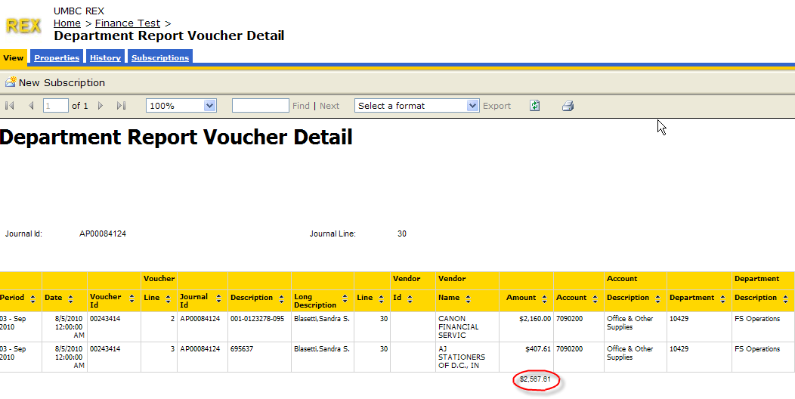

- To return to the initial report menu, you have two options:
  - Use the IE “back button” .
NOTE: This method is recommended as it will return you to your initial report without requiring re-entry of the parameters. While the back button is useful in T-REX, please remember NOT to use it in PeopleSoft applications!

ADDITIONAL NOTE: If you drilled to voucher level detail, you will need to click the IE “back button” twice to return to your initial report.

  - Use the “breadcrumbs” to the right of the yellow T-REX wording.



NOTE: This method will take you back to the initial reports page and requires re-entry of your report parameters.

- If you know the account number or name on which you want the detail, you can navigate directly to the Department Report Detail report from the home screen.

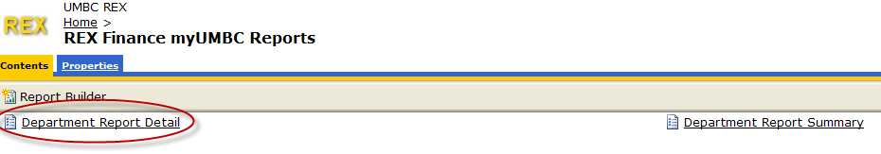

- Click on the Department Report Detail Link and the navigation page appears.

- Select the Fund, Fiscal Period, Account, and Department Number or Name as described above on pages 13 and 14 (Numbers 11-14). Remember to type multiple numbers and/or letters QUICKLY in order to have the search function sort properly.

- NOTE: When navigating directly to the Detail Report, you must also select either “YTD Through” or “Current” (indicating fiscal period selected month data only) from the additional dropdown menu.

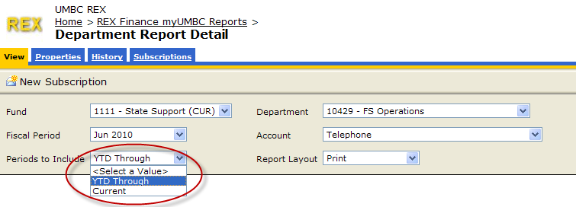

- Once the field parameters are selected, click on view report to generate the detail report requested.
- The detail report then appears (Note: in this example the same report as the one above generated by drilling from the summary report on the telephone link appears.)

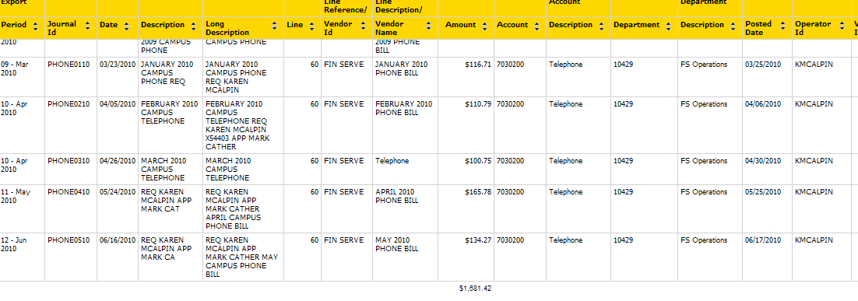
- Logout of T-REX by clicking the “X” on the top right of the IE page (there is no “logout” or “sign out” button) to close your browser session.

Exercise:

Use one of your own department numbers (or names) to generate a summary report.
Once the report is generated, expand to account level detail.
Now drill to detail on an account in operating expenses.
Change the sort order to sort ascending by amount.

Printing a Report

- To print a report, run the report and click on the Print icon.

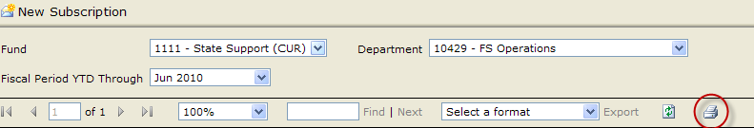

- A page displays to let you set some formatting and printer options. You may choose to “Preview” or just select “OK” to send to printer.

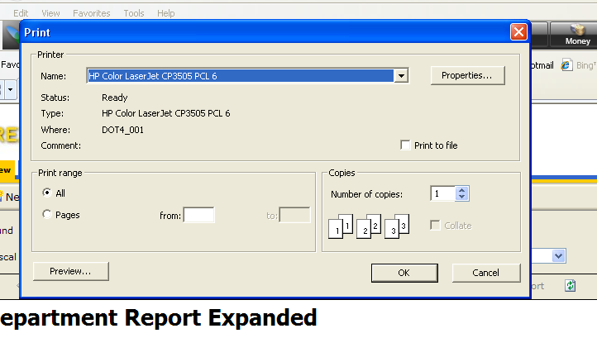

- NOTE: You may have to download some additional programs the first time you attempt to print.

- The reports are pre-formatted to print on 8^{1/2”} X 11” paper in landscape. You should not need to adjust any of the settings.

Setting up automated e-mailing of reports!

- Click on the “New Subscription” box in the upper left of the “View” tab (You can also access the same screen from the “Subscriptions” tab.)

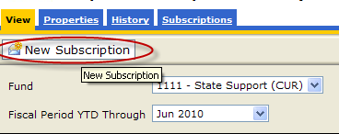

- The following screen appears:
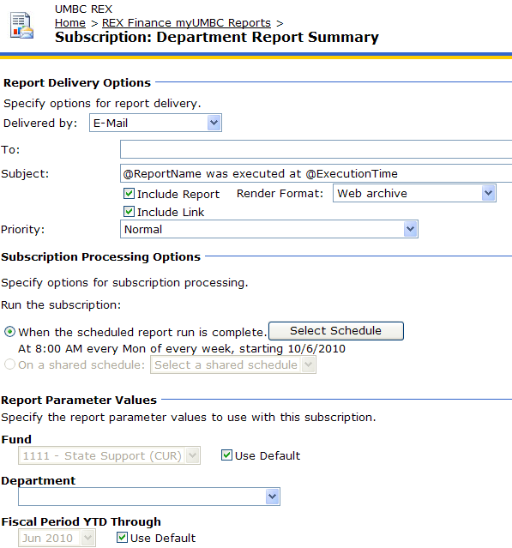
- Use default “Delivered by” methodology of e-mail.
- Select Schedule to choose timing of the report to be delivered. (NOTE: Do this prior to entry of e-mail addresses! If you change the order, the e-mail address will be lost after saving the Schedule you selected.)
  - Click the button. The following screen appears:

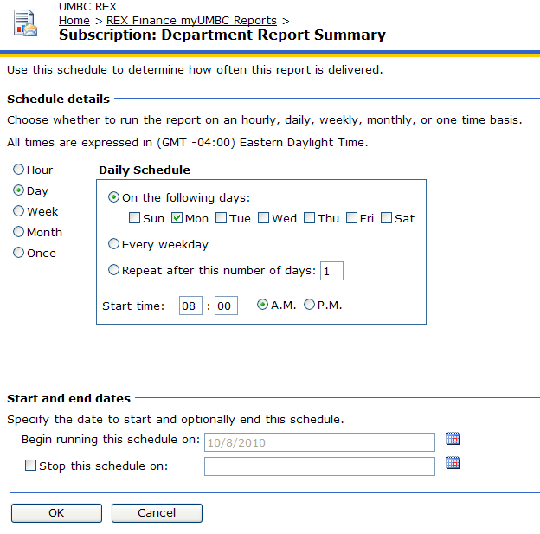
  - Select a radio button indicating frequency of report (Hourly, daily, weekly, monthly, or once). NOTE: As T-REX is updated nightly, “Hourly” selection will not be very useful.
  - The Schedule box (picture above as “Daily Schedule”) will adjust based on choice in b above. Select the appropriate options in the schedule box.
  - Click the check box “Stop this schedule on:” to assign a date on which to end the running of the report. Note: You must use the calendar icon to select a date.
The page does not allow for direct entry of a date. If not checked, report will run until deleted from subscriptions.
  - NOTE: In order to ensure that the nightly load of data has completed prior to running of your report, be sure to set the time of day to 8:30AM or later.
  - Click “OK” to save schedule selected. This returns you to the Subscription page.

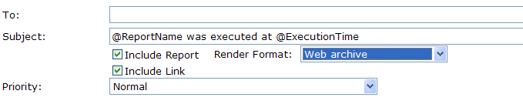
- Enter e-mail address(es) of recipients of the report in the “To:” field.
- NOTE: In order to enter multiple e-mail addresses, separate each address with a semi-colon. Incorrect entry of multiple e-mails will result in an error message.
- The “Subject” line default will produce a header with the report name and time stamp. As an example: Department Report Summary was executed at 10/7/2010 1:15:08 PM.
- To overwrite the Subject, type your chosen subject language in the “Subject” line.
- Check the “Include Report” checkbox to include the report as attachment in the format selected in the “Render Format” drop down list.
- Check “Include Link” checkbox to include a direct hyperlink to the report in your e-mail.
- Priority defaults to Normal. You may use the dropdown to select “high” or “low”.
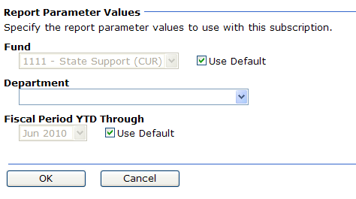
- Choose Report Parameter Values by 1st clicking OFF the “Use Default” checkbox. NOTE: As there is no default department, you must choose parameters. If not, the report will not produce any results.
- Use the drop down lists for each field (in this example: Fund and Department) to choose the desired parameters.
- You may choose to use the default fiscal period or uncheck the “Use Default” box to allow use of the drop down menu to change the fiscal period.
- HINT: Choose the default period on a monthly report and run on the 10th of the month in order to produce a report that will coincide with month end close the majority (~90%) of the time. The system is programmed to run the prior month through the 10th day of the following month.
- Click “OK” to save. This returns you to the report view page.

- To end auto e-mailing of the reports, go the subscriptions tab and select the subscription you wish to delete.

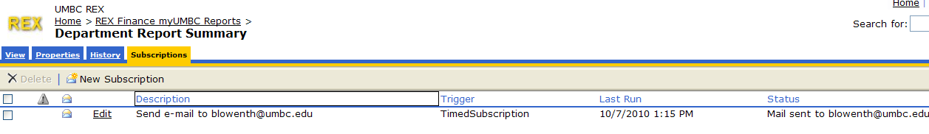

- Once the subscription is selected, the “Delete” button becomes available. Select Delete.
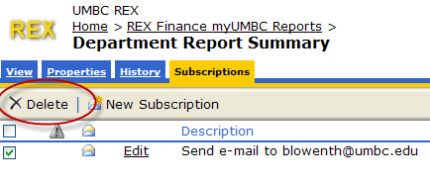

Export to Excel!

All reports in T-REX/iStrategy can be downloaded to Excel by simply selecting the desired format and then clicking the Export link.

- Select a format from the dropdown menu and then click the Export button (highlighted below).
NOTE: Prior to selecting a format the “Export” button will be grayed out. The link becomes active after selecting a format.

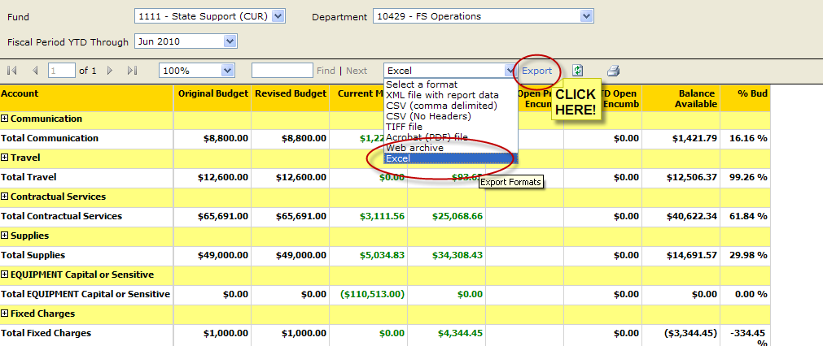

- The following screen appears.

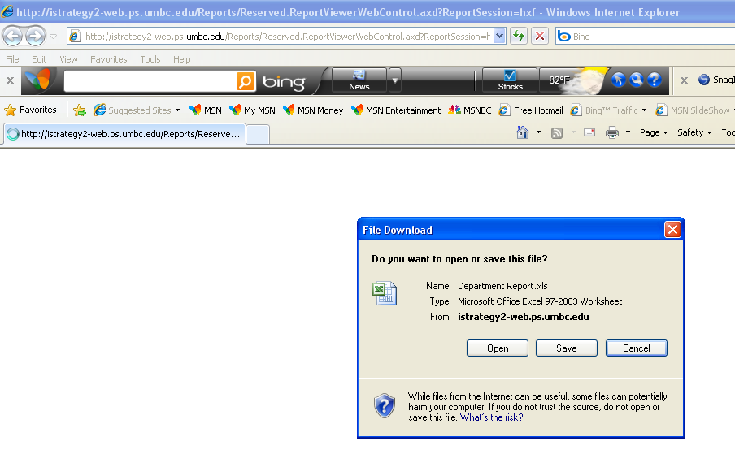
- Click on the “Open” button (or “Save” if you wish to save directly to a file). An Excel spreadsheet then opens automatically with your report displayed.

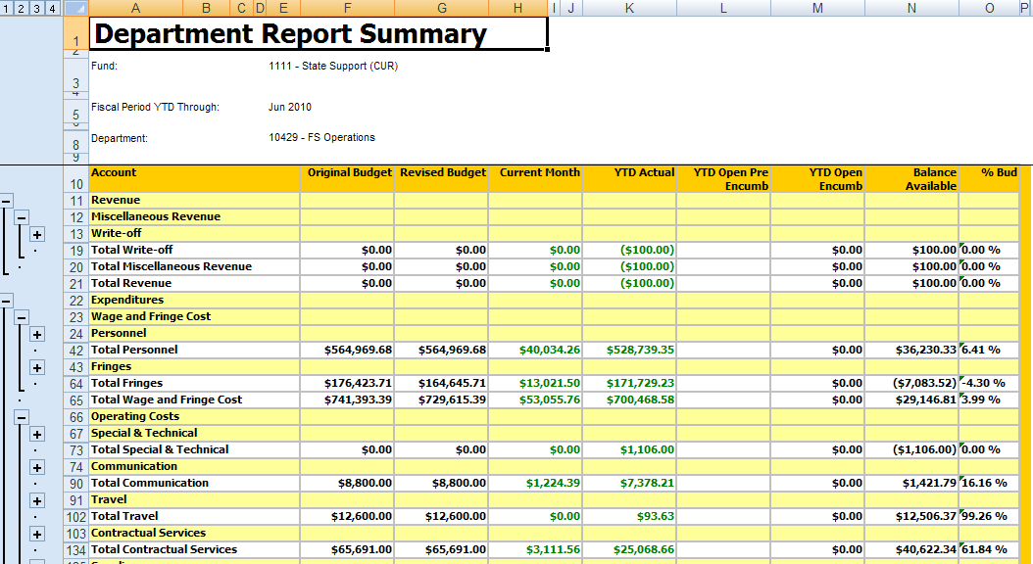

- The outline format to the left can then be used to expand to detail or contract to summary across the entire report with one click. Click on the numbers to easily move between levels. Clicking on the Number 4 (highlighted) expands to the lowest level of detail.

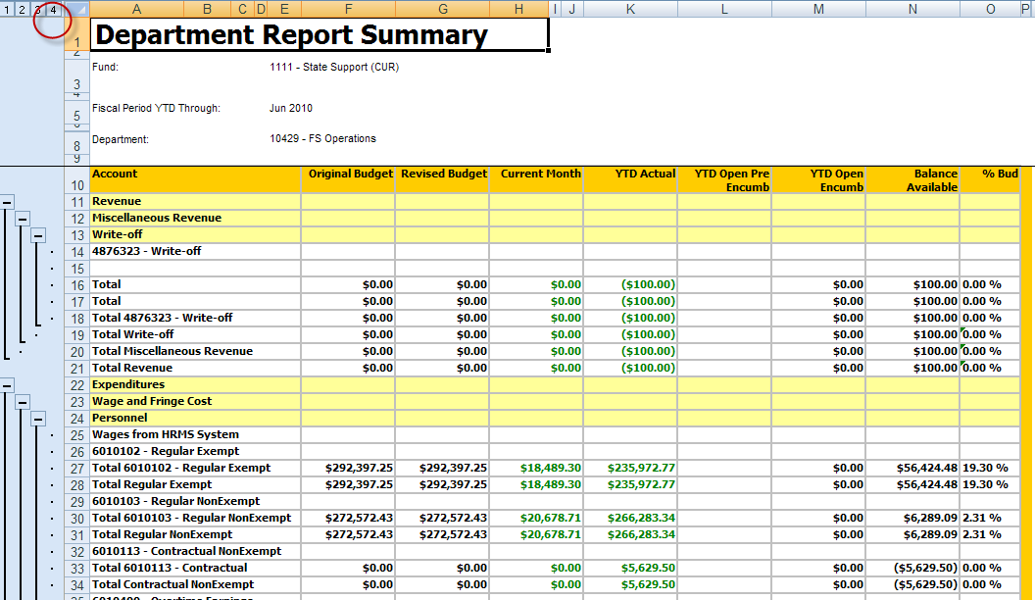

- NOTE: The Excel spreadsheet retains the drilling capability. Click on any green link number to create a detail report in T-REX. (NOTE: You will be prompted to login to iStrategy prior to being able to run the drill report.)

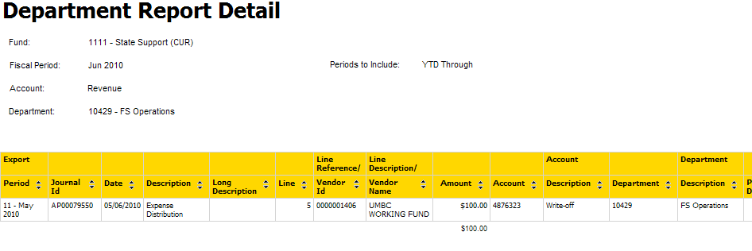

Getting Help

To access help and documentation, click on the help link in the upper right corner of the report.

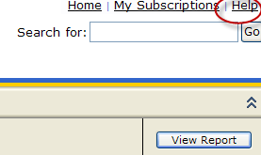

The link will direct you to the Help Page on View Reports which details some of the material in the documentation above.

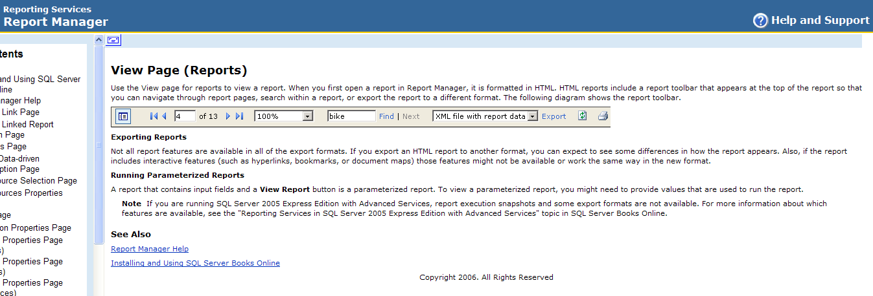

You may use the other links in the “Help Contents” area of the page (to the left) for additional information. Much of this is more pertinent to developers than end-users.

Mailing Lists

Two mailing lists exists for sharing information about T-REX.

Your name will be added to these lists automatically after completion of this training. You will be e-mailed confirming your addition and given an option to “opt out”. As information shared via these lists is critical (e.g. – Issues regarding load of T-REX data), please do not opt out!

REX-announce@lists.umbc.edu – Informational list to provide information about updates, availability, etc.
REX-users@lists.umbc.edu – Interactive list to allow sharing of questions, ideas, etc. between users of T-REX.

Module 3: Future of T-REX

- Charts/Graphs (Available only via T-REX ProClarity – Access limited to select group of Power Users)

Expenditure by Category – June 2010

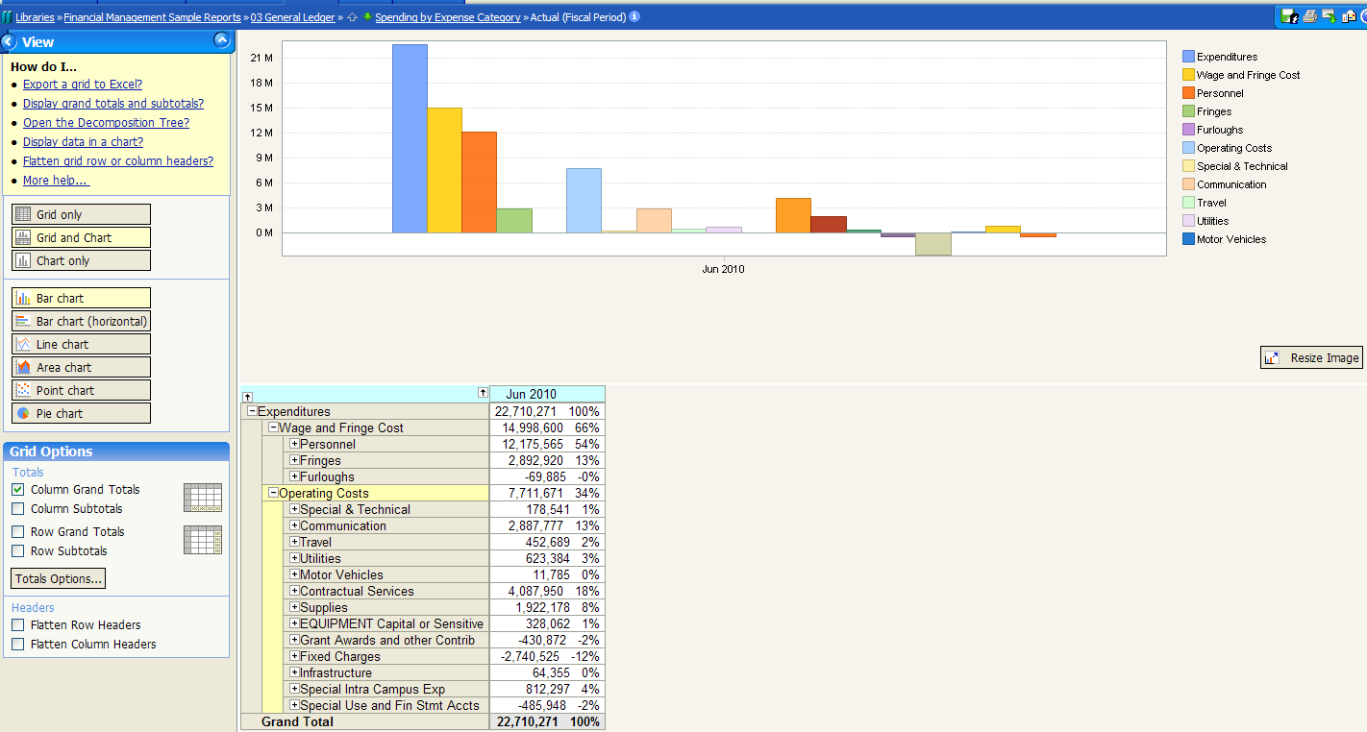

Budget by Fund and Expense Category

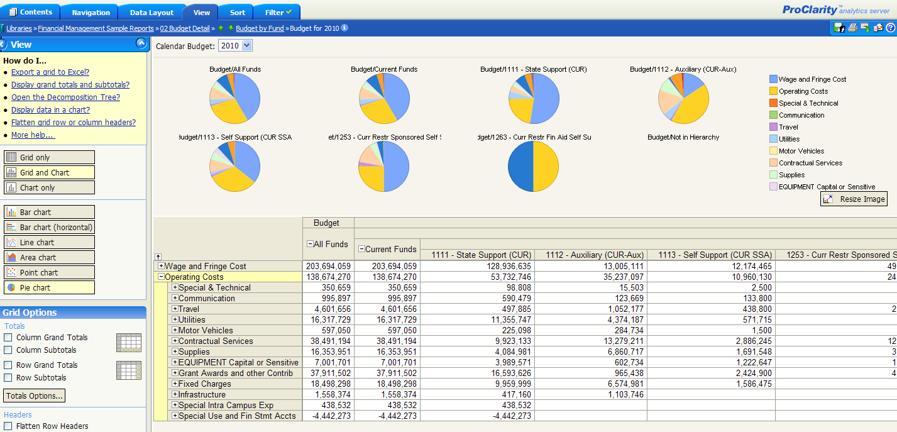

- Time Series

Revenue vs. Prior Year (Available only via T-REX ProClarity – Access limited to select group of Power Users)

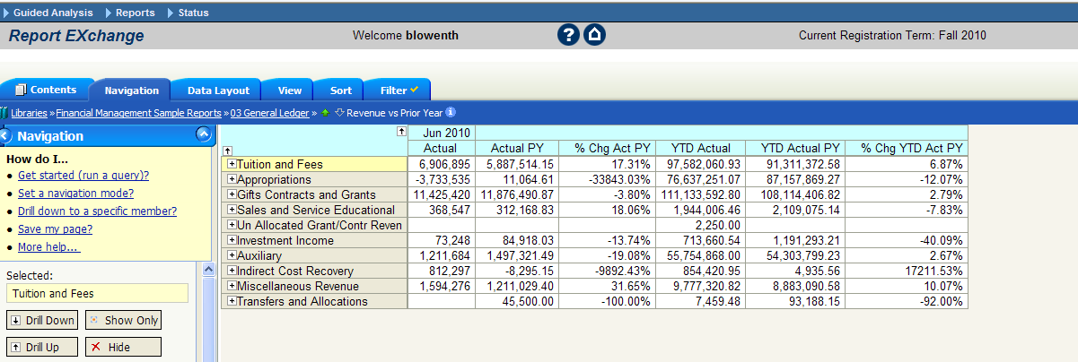

Future reports to include:

- HR/Payroll detail reports (Equivalent to EEPAY)
- Grant reports (Summary and Detail)
- Inclusion of other funds (1113, 1114)
- Building of reports for other current Retriever reports

APPENDIX I: Reconciling T-REX to PeopleSoft

IMPORTANT NOTES !

- DO NOT RECONCILE USING RETRIEVER AS DATA WILL BE DIFFERENT!

- Actuals balances will be reconciled daily by Financial Services to assure accuracy. Following the procedures below will allow you to confirm your own department’s numbers. While you are encouraged to review your data consistently and alert us to any issues, reconciliation to PeopleSoft as described below is NOT required. It is an option for you to get comfortable with the numbers.

- Budget data will be reconciled weekly by the Budget Office to ensure accuracy.

- Encumbrance and pre-encumbrance data will not be reconciled by Financial Services.

RECONCILIATION PROCESS

- Reconcile actuals data first.
- Download the T-REX report for your department to Excel and expand to lowest level by clicking on the highest number in the upper left corner of the spreadsheet as in “Export to Excel” Step 4 above (pages 26-27).
- Run the following report in PeopleSoft in order to pull the same comparative data directly from the General Ledger:

GL Trial Balance Report

- In PeopleSoft, navigate to: General Ledger >>> General Reports >>> Trial Balance (see red circled menu items below). The following page appears:

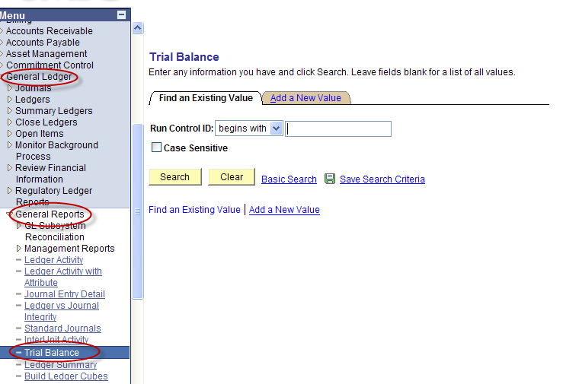

- If you have previously entered a Run ID, click on for a list of your Run IDs and select one.

- If you have not previously entered a Run ID, click on the  Tab and create a new Run ID (I recommend putting your initials in the run ID but this is not required).

- Select the Run ID to arrive at the following page:

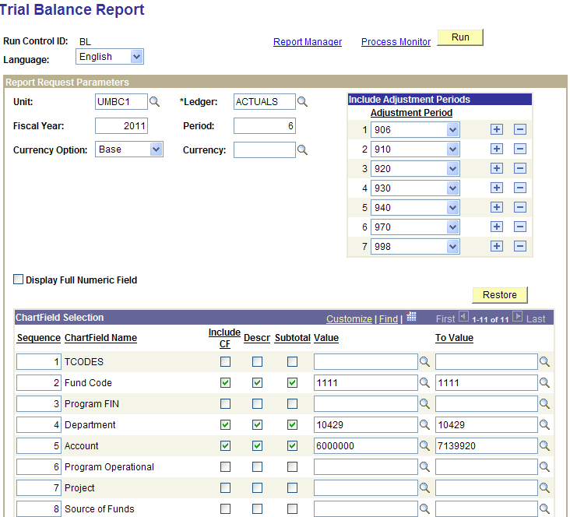

- Fill in the required fields as above depending on the period for which you ran the T-T-REX report.
IMPORTANT: Be sure to enter the same “Fiscal Year” and “Period” on the Trial Balance report as you selected for the T-REX report!

- Enter the Fund you wish to reconcile (Should be either 1111 or 1112). Check all boxes (see above example; “Include CF”; “Descr”; “Subtotal”). Be sure to enter in both the “Value” and “To Value” fields (tabbing through will automatically repeat the value entered in the 1st field to the 2nd field).
- Enter the Department you wish to reconcile (Be sure it matches the department you are reconciling to in T-REX!). Check all boxes (see above example; “Include CF”; “Descr”; “Subtotal”). Be sure to enter in both the “Value” and “To Value” fields (tabbing through will automatically repeat the value entered in the 1st field to the 2nd field).

- Enter the Accounts you wish to reconcile (NOTE: Using the accounts entered in the above example will guarantee that all expense accounts are included. Use 4000000 to 5833720 to capture all revenue accounts). Check all boxes (see above example; “Include CF”; “Descr”; “Subtotal”). Be sure to enter in both the “Value” and “To Value” fields.

- Once all fields are entered, click and track the report to success in the Process Monitor. (Choose “web” for “Type” and “csv” for Format).

- The report should look similar to this:

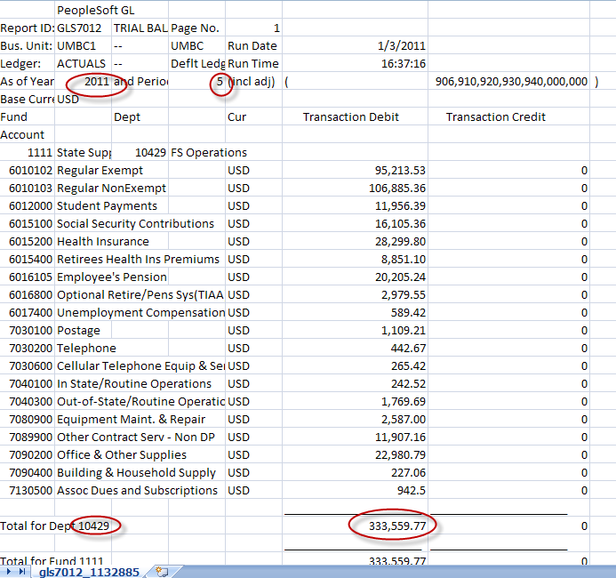

- NOTE: You will have to do the math yourself to total debits and credits (if applicable).

- Recommended Step 1. Compare total expenses in the Trial Balance Report to total in T-REX. If they agree, you can stop here. (See below for the T-REX report with matching totals.)

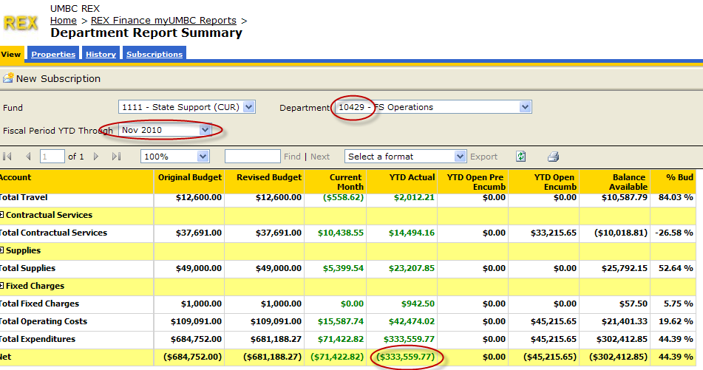

- If they do not agree, you should then compare by accounts to identify where the discrepancy might be. (In most cases, there should not be any).

- You can then follow the same process for revenues. (If applicable)

- Reconcile Budget Numbers next.

- Navigate to the Budget Status report in PeopleSoft by (if you need access and do not have it, please e-mail Gayle Chapman at chapman@umbc.edu and she will request the appropriate access for you).

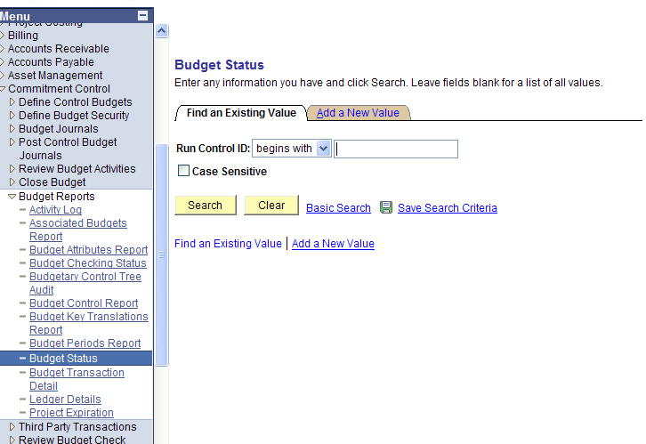

- If you have previously entered a Run ID, click on for a list of your Run IDs and select one.
- If you have not previously entered a Run ID, click on the Tab and create a new Run ID (I recommend putting your initials in the run ID but this is not required).

- Select the Run ID to arrive at the following page:
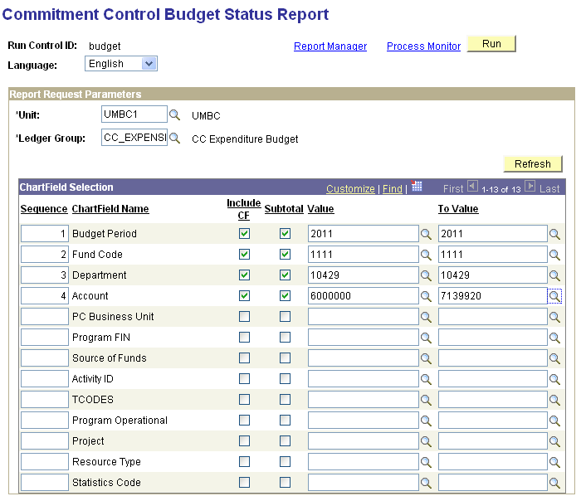
- Please note that you must run revenue and expenses separately. The entire list can be found by clicking the magnifying glass.

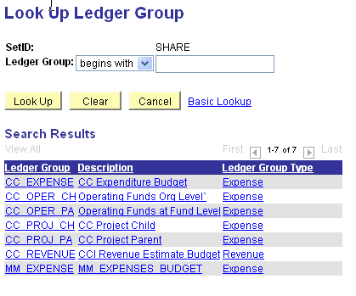
- Choose CC_EXPENSE or CC_REVENUE .
- Fill in the required fields as above depending on the period for which you ran the T-REX report.
  - Please note that you cannot pick a period in Budget Status. Be sure to enter the same “Fiscal Year” on the Budget Status report as you selected for the T-REX report!
- Enter the Fund you wish to reconcile (Should be either 1111 or 1112). Check all boxes (see above example; “Include CF”; “Subtotal”). Be sure to enter in both the “Value” and “To Value”.
- Enter the Department you wish to reconcile (Be sure it matches the department you are reconciling to in T-REX!). Check all boxes (see above example; “Include CF”; “Subtotal”). Be sure to enter in both the “Value” and “To Value”.

- Enter the Accounts you wish to reconcile (NOTE: Using the accounts entered in the above example will guarantee that all expense accounts are included. Use 4000000 to 5833720 to capture all revenue accounts; 6000000 to 8873600 to capture all expense accounts). Check all boxes (see above example; “Include CF”; “Subtotal”). Be sure to enter in both the “Value” and “To Value”.

- Once all fields are entered, click and track the report to success in the Process Monitor. (Choose “web” for “Type” and “csv” for Format).

- The report should look similar to this: 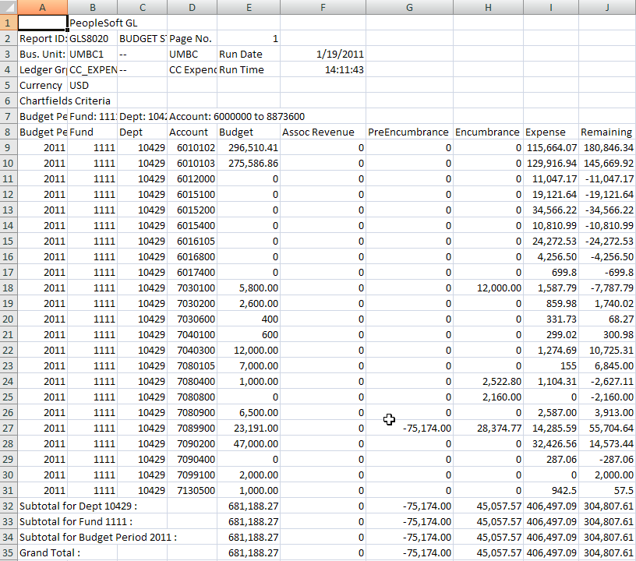
- Recommended Step 1. Compare total budget for expenses (column E) in the Budget Status Report to total in TT-REX. Do the same for revenues. If the totals agree, you can stop here. (See below for the TT-REX report with matching totals.)
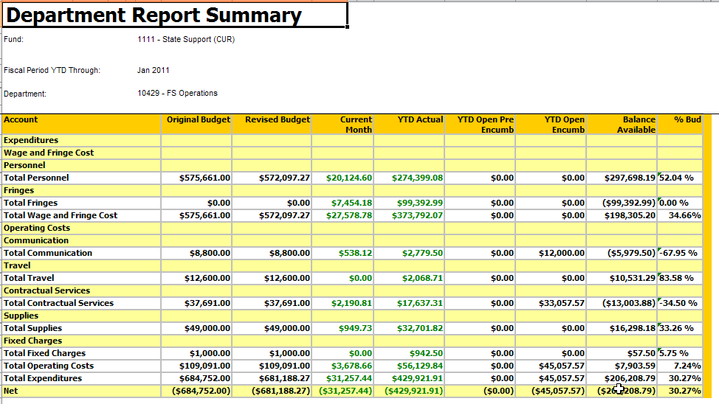
- If they do not agree, you should then compare by accounts to identify where the discrepancy might be. (In most cases, there should not be any).

- APPENDIX II: Connecting to the VPN

- Open Microsoft Internet Explorer

- Go to http://vpn.umbc.edu

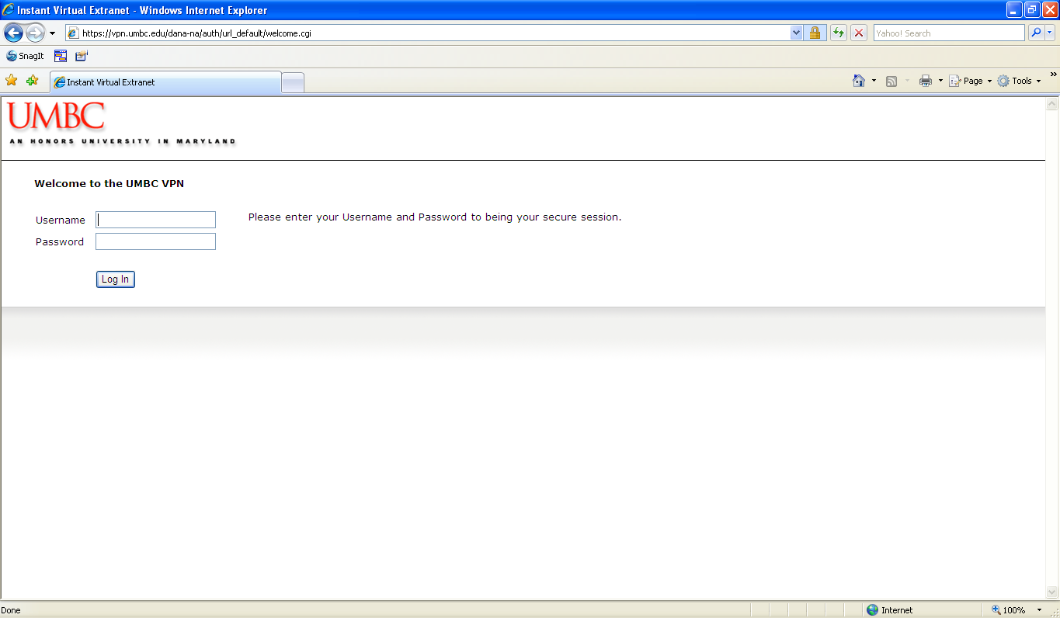

- Enter your Username and Password and click the ‘Log In’ button

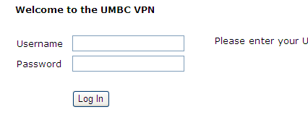

- The UMBC VPN home page displays

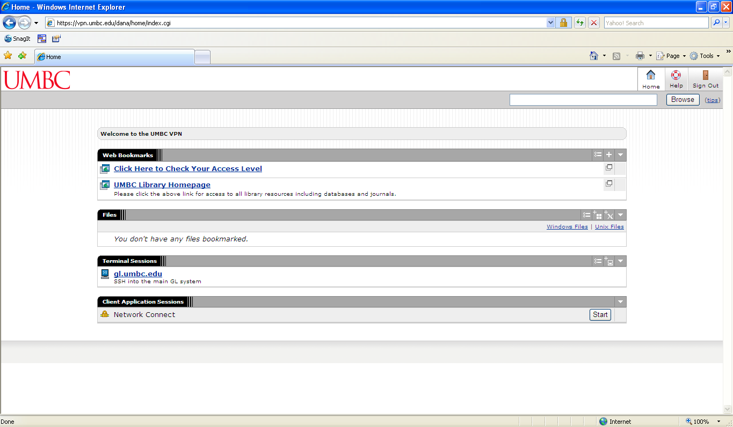

- Click the ‘Start’ button

