

A N H O N O R S U N I V E R S I T Y I N M A R Y L A N D



SITES.UMBC.EDU

*After you complete your training and set up your Sites page, remember to log into http://my.umbc.edu/groups/sites to join your Sites User Group community to find other sites users on campus.
Sites User Groups are a great way to ask other Sites members questions, share comments, and receive the latest updates in Sites news. *

INDEX

Subject | Page#
Cover Page | 1
Index | 2
Requesting a UMBC Sites Page | 3
Getting Started | 4
The General Dashboard | 5
My Sites | 6
Pages | 7
The Page Library | 7
Adding New Pages | 8
Template Options | 9
Pasting Text into the Text Box | 10
Text Editing Tool Bar | 10
Hyperlinks in the Text Box | 11
Displaying myUMBC Group Content on Sites pages | 12
Displaying UMBC Directory Listing on a Sites page | 12
Customizing Directory Listings | 13
Adding Media to a Page | 14
Embedding a Media | 15
Embedding a Google From | 16
Embedding a Google Calendar | 17
Editing Image Format in the Text Box | 18
Making Buttons Using Images | 19
Slideshow | 20
Appearance | 21
Widgets | 22
Types of Widgets | 23
Menu | 24
Creating a Menu Item That is a Link | 25
Making Un-clickable Menu Items | 25
How to Add a Banner | 27
How to Add Page Footers | 27
How to Change the Sites Colors | 27
Custom Color | 27
How to Use Your Google Analytics Account with Sites | 28
Users | 29
Adding a User | 29
Removing a User | 29
Settings | 29
myUMBC Groups Page | 29
How to Create a myUMBC Groups Page | 30
Getting Started on Your myUMBC Groups Page | 30
myUMBC Group Posts | 31
myUMBC Group Events | 33
Setting a Thumbnail for Your Event, News, or Spotlight | 35

Requesting a UMBC Sites page:
- Go to sites.umbc.edu.
- On the site.umbc.edu home page click on “Fill out this Form” under “Request Site.”
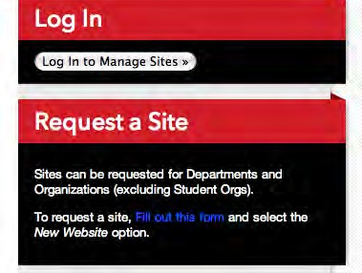

- This link will take you to the UMBC log in page. Sign in with your normal UMBC username and password.
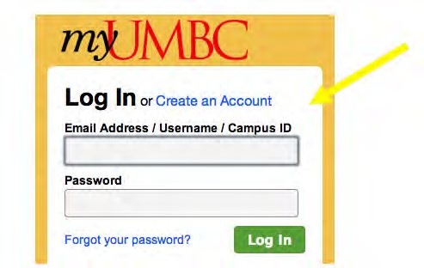

- Fill out the form and click “Submit.”
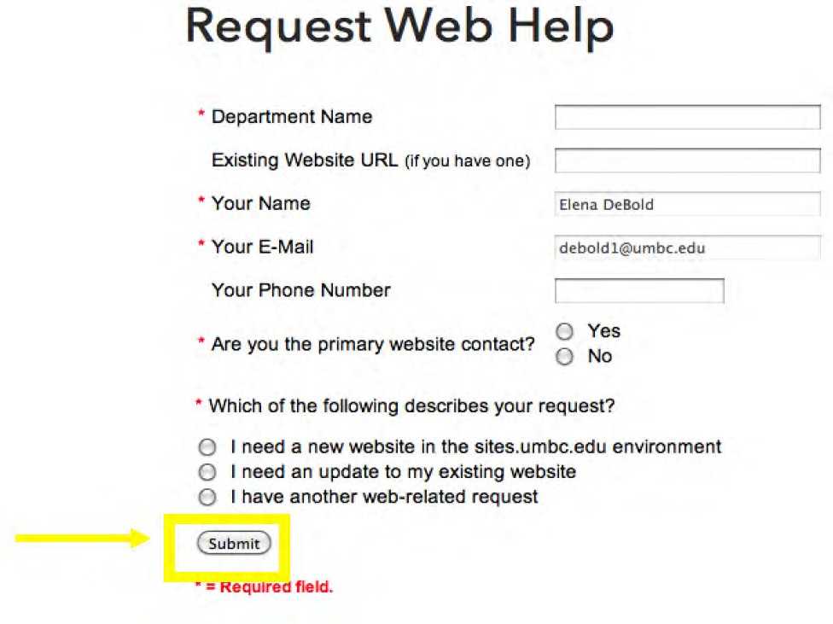

Getting Started:
- After your Site has been created, go to sites.umbc.edu and click “Log In to Manage Site” under “Log In” on the right side of the page.
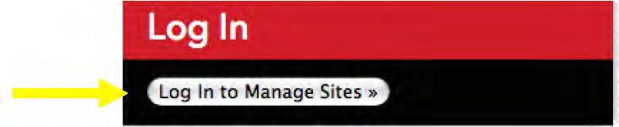

- This link will take you to the UMBC log in page. Sign in with your normal UMBC username and password.

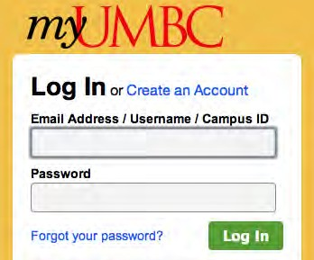

- Once you log in you will be directed to the “Dashboard” of your Sites page, which will look like the image below:
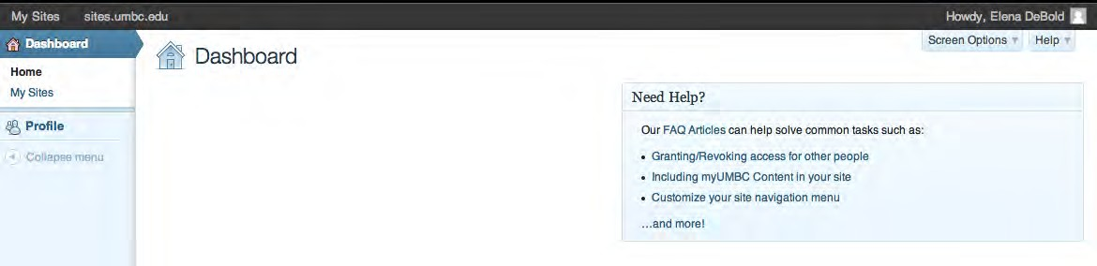

- Warnings and Maintenance: Sometimes you will see a banner at the top of the sites page stating a warning from the UMBC Alert System or maintenance information regarding Sites. This banner will look similar to the following:

The General Dashboard:
Once you sign in to your Sites page you will see the following page known as the Dashboard:
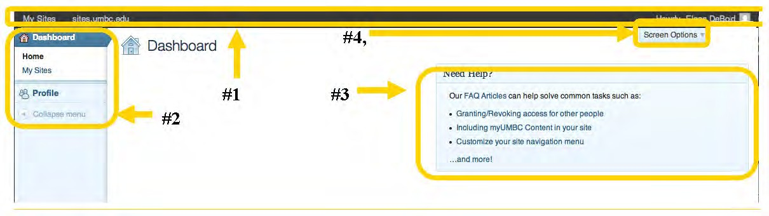

The General Dashboard: This is the behind the scenes of your Sites account. Once you go to “My Sites” and select the site you want to edit, you will have another Dashboard for that particular Sites Page to learn more about your Sites Dashboard go to Page 4.

Before going any deeper into the Dashboard, there are a few things to recognize which could help you later on:

#1-Top Menu Bar:
- My Sites: First on the dark gray bar at the top of the page there is a drop down titled “My Sites.” This drop down will list the Sites that you are approved to edit.
- Sites.umbc.edu: Next on the dark gray bar is “sites.umbc.edu.” This link brings you back to the main Sites page that you signed into earlier.
- Howdy, (your name): Furthest to the right on the dark gray bar is “Howdy, (your name).” Clicking on this button will bring you to your profile page where you can edit personal options such as your profile, contact information, and your bio.

#2-Left Side Bar:
- Dashboard Options: The “Home” and “Dashboard” options on the sidebar both bring you back to this Dashboard page.
- My Sites: In addition to “My Sites” on the dark gray menu bar, “My Sites” on the side bar takes you to the list of Sites that you are approved to edit.
- Profile: This is another way to get to your profile page.

#3-“Need Help?” box:
- The “Need Help?” box is linked directly to a Wiki Help page that OIT has created for Sites. You can also get to the Wiki Help page by going to: http://umbc.edu/go/siteshelp

#4-“Screen Options” drop down:
- This shows options for placement of the “Need Help?” box on the Dashboard.

My Sites:
Under “My Sites” you will see all the Sites that you are approved to edit.
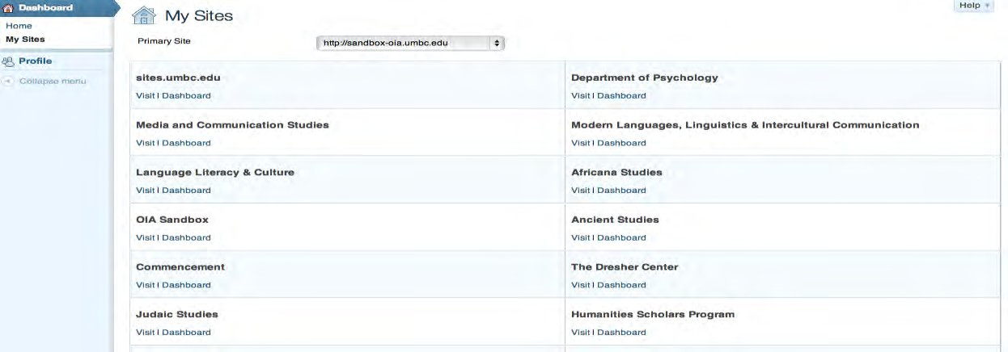

Under each site (you may only have one site listed) you will see “Visit” and “Dashboard.” “Visit” takes you to the view of the Site that your audience can see (or would be able to see if your Site is not yet live).
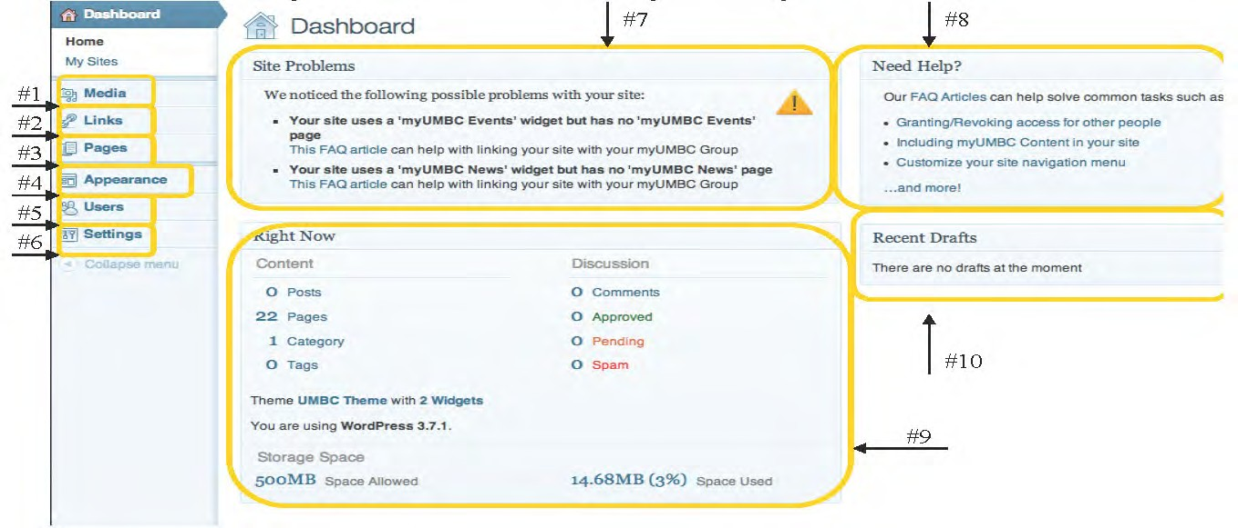
The “Dashboard” link takes you to the behind the scenes where you can edit your Site.
#1- Media: The Media Library is where your images, videos, and documents will be stored.
#2-Links: This area stores the links that you have used on all of your pages.
#3- Pages: In this section you can create new pages and edit old ones. Also in this area is the page library, which lists all the pages that have been created. These pages make up your website.
#4- Appearance: This area is where you will be editing the appearance of your website including the banner and the color pallet.
#5- Users: Here, you can add or remove users who can edit the site.
#6- Settings: General settings for your Site.

#7- Site Problems: In this box you will find automatically generated warnings. These issues may or may not cause problems with your site. If you have questions consult the Wiki help page or contact UMBC’s Division of Information Technologies.
#8- Need Help?: Just as on the main dashboard page, this is where you can link to the Wiki Help page.
#9- Right Now: This box shows you the statistics of your site including the number of Pages and how much space you have used.
#10-Recent Drafts: This box will show you recent drafts of Pages which have not been published yet.

Pages
Pages are the actual web pages your Sites page is made up of. When you go to Pages, you will see two options, “All Pages” and “Add New.”
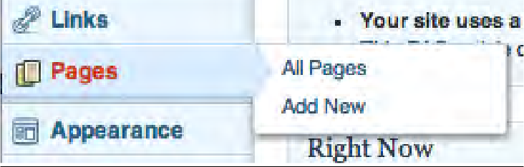
“All Pages” takes you to a library of all the pages you have created. “Add New” will create a new page for you.

The Page Library:
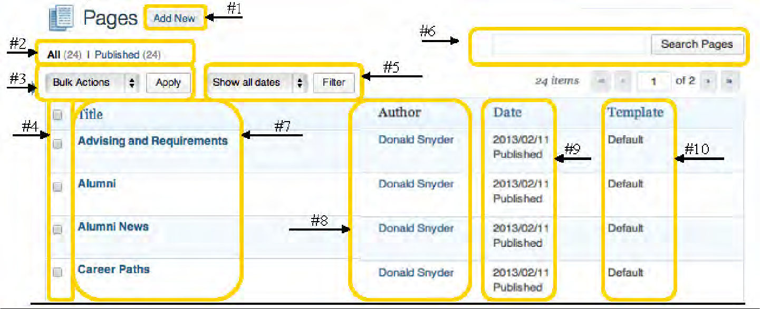
#1-Add New: You can use this button to create a new page.
#2-All/Published: This is the total number of pages on the site and the number of those pages that have been published.
#3-Bulk Actions: Bulk Actions are actions you can do to multiple pages at one time. These include “Move to Trash” and “Edit.” To select pages for Bulk Actions just check the box next to each page title (#4) then select the Bulk action you want to accomplish and press “Apply” next to the “Bulk Actions” drop down menu.
#4- Selection Boxes for Each Page: If you select the first box in the column, all pages will be selected.
#5- Date Filter: To find pages you can filter the pages by date. Just select the date you are looking for and click the “Filter” button.
#6- Search Pages Bar: You can also find pages by typing key words into the Search Pages bar.
#7-Title: Under “Title” you will find the title of each page.
#8-Author: Under “Author” you can find the author of each page.
#9-Date: Under “Date” is where you will find the date that the page was last edited or published and whether the page is a draft or published page.

#10-Template: Under template you can see which pages have which template. In Sites we will mostly be using the “Default Template.”

Adding New Pages:
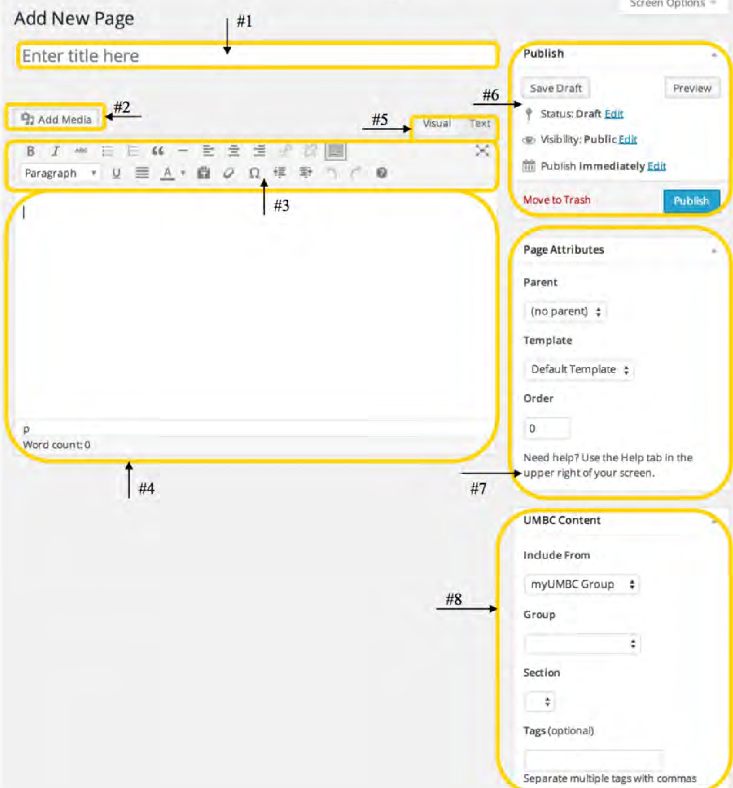
To add a new page, click the “Add New Page” button in the Page Library or on the sidebar menu. Once you have selected “Add New Page” the following page will appear:
#1-Title Bar: This is where you put the title of the page. This title will be shown on the page as well as in the menu bars on your site.
#2- Add Media: You will use the “Add Media Button” to add media, such as images and documents, to your page (this is covered in more detail on page 9).
#3-Text Editing Tool Bar: You will be using this menu to edit and format the text in the text box (#4). The Text Editing menu is covered in more detail on below.
#4-Text Box: The text box is where all of the content for the page goes. This includes text, links, and media.
#5-Visual/Text Tabs: These two tabs are the two sides of the text box. The tab titled “Visual” is the visual side of the text box, which shows you how the page looks. The tab titled “Text” is the HTML side of the text box. We highly suggest that you edit only on the “Visual” side of the text box unless you are proficient at HTML coding.

#6- Publish: In this area you can change whether or not the page is public or a draft. You can also save drafts, set a date for the page to be published, send the page to the trash, or preview the page.
#7-Page Attributes: Here you set the template for your page. Again most pages will be under the “Default” template. Your homepage should always have the “Home Page” template selected. If you choose to have myUMBC News and Events pages you will set the template to “myUMBC News” or “myUMBC Events.” Other than the template, you should leave all the settings in the “Page Attributes” menu the way they are.
#8-UMBC Content: In this area you can set the page to bring in certain information from a myUMBC users group.

Template Options:
Default Template: Basic page layout  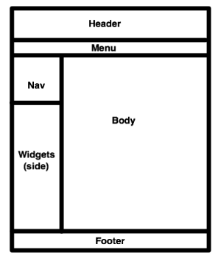 | Home Page * : Special home page layout, with available myUMBC Spotlights and special widget area  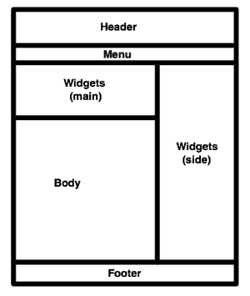
Full Width: Full page layout
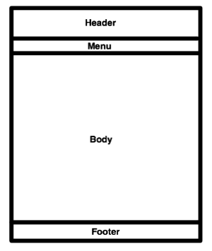

Pasting Text into the Text Box:
If you do not strip the formatting or type the text directly into the text box, you could end up with strange formatting or several spaces between lines. With the Text Editing Tool Bar explained on p. 10, you can reformat the text once you have stripped it and pasted it into the text box.

*IMPORTANT: The text box automatically defaults to double spaces. When typing the text box you can press enter and hold down shift. This will single space the lines.*

Text Editing Tool Bar:
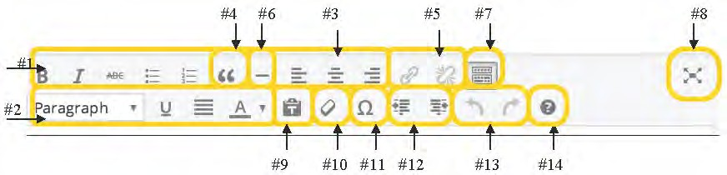
#1, #2, & #3: Here is where you find the more common text editing items such as lists, bolding, and alignment.
#4-Block Quote: The Block Quote tool can be used for creating a box for text in order to separate the text from the rest of the page.
#5-Hyperlink Tool: The Hyperlink Tool is used for inserting links to exterior pages or pages within the site. The chain link to the left is used to create a hyperlink whereas the breaking chain on the right is used to disable a hyperlink. The Hyperlink Tool is covered in more detail on page 11.
#6-Horizontal Line: The Horizontal Line tool draws a line across the text box. This can be helpful for separating sections of content.
#7-Show/Hide Kitchen Sink: With this tool you can hide or show the second row of the Text Editing Tool Bar.
#8-Distraction Free Writing Zone: This changes the view of the text box so it takes up the whole screen.
#9-Paste as Text: Using this paste tool can help with the formatting of the text but sometimes are not as precise as if you had formatted the page in the Text box on Sites. Thus we recommend you do your text formatting directly in the Text box.
#10-Remove Formatting Tool: This tool is used to remove the formatting of text so that the text can be reformatted. This is especially useful if you copy and paste text in from another source. To remove the formatting, select the text that you want to erase the formatting on and press the button.
#11-Insert Custom Characters Tool: Use this tool to insert different symbols or characters such as arrows or letters with symbols (like tildes) over them. This is helpful if you are using different languages or math equations on your page.
#12-Indent and Outdent Tools: Use these tools to indent or outdent text.
#13-Undo and Redo Tools: Undo or redo actions completed within the text box.
#14- Keyboard Shortcuts: Here you will find a helpful list of shortcuts for editing and formatting your text.

Hyperlinks in the Text Box:
- To create a hyperlink, the first thing you want to do is select the text you want hyperlinked in the text box.
- With the text selected, press the Hyperlink Button in the tool bar (the one that looks like a chain linked together).
- After pressing the Hyperlink Button, the following page will pop up. Fill out this page.
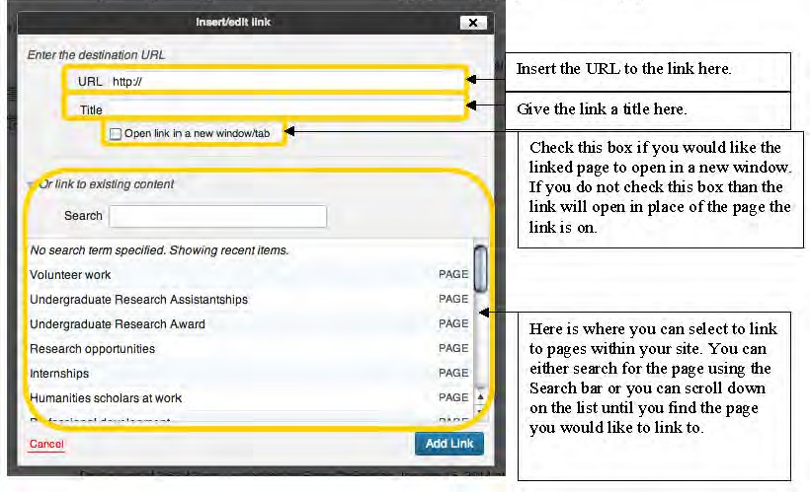

- Once you have filled out the above Link Insert/Edit page, press the “Add Link” button.

Displaying myUMBC Group Content on Sites pages:
Any page in your site can include News, Events, Discussions, or Media created by a myUMBC group.

IMPORTANT: You can dedicate an entire page to your myUMBC News, myUMBC Events, Media, and Discussions, which will automatically update the content whenever you update those sections of the myUMBC group. If you also want widgets that pull in myUMBC group content, they will automatically link to your myUMBC group pages on your Sites page rather than back to your myUMBC group page. Thus we strongly recommend creating matching myUMBC group pages if you have myUMBC group content being pulled into widgets. To learn how to create widgets incorporating myUMBC group content go to page 22.

- Edit the page on which you wish to include content created by a myUMBC group.
- Select the "myUMBC Group" option from the UMBC Content section.
- The "Group" dropdown includes myUMBC Groups your site has recently added. If the myUMBC Group you want to use is not in the list, select "Add New Group,” type in the myUMBC Group Token or the URL of the myUMBC Group homage, then click "Add.”
  - What is a myUMBC group token:
When viewing a group in myUMBC, the "group token" is visible as part of the website URL: "my.umbc.edu/groups/group-token.” For example:
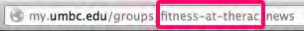
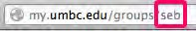
(the group token is "fitness-at-therac") (the group token is "seb")

- Once a myUMBC Group is selected, pick the Section you wish to include content from.
  - You can optionally specify tags, which filters the content shown to items containing at least one of the specified tags.
- Save the page.

Displaying UMBC Directory listing on a Sites page:
When editing a page, you want the directory listings to show:
- Select "Directory Listing" from the UMBC Content section.
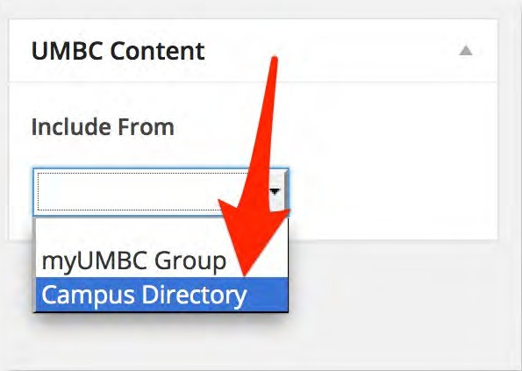

- You can now select your department from the dropdown in the "Basic Listing" section.
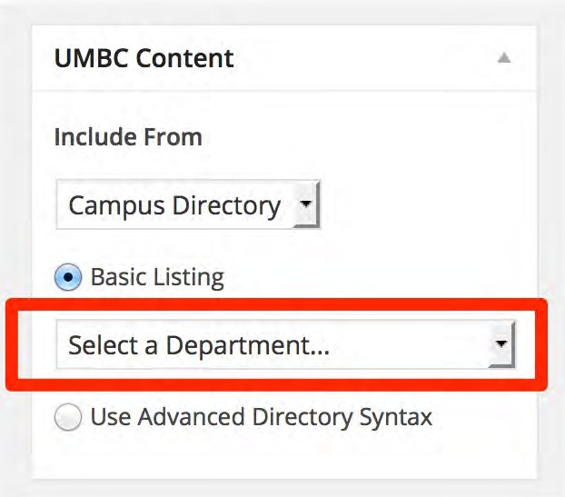
- If the information or formatting from the automatically generated directory is not correct, you could select the "Use Advanced Directory Syntax" option to create your own custom directory listing (directions below/on the next page).

Customizing Directory Listings:
You can use the Advanced Directory Syntax to customize who is shown in a directory listing.
- First, ensure that the page includes "Campus Directory" information, and that you selected the "Use Advanced Directory Syntax" option.
- Once selected, you can include the Advanced Directory Syntax along with any other page content using the Visual page editor. An example of the syntax is as follows:
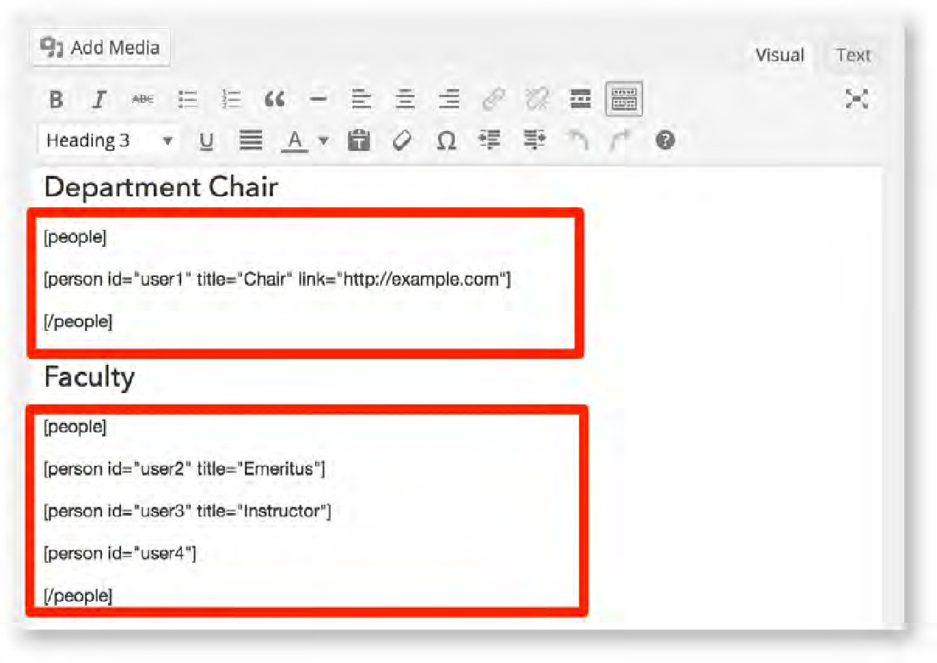

- Each listing starts with a [people] tag, contains one or more [person] tags inside, and ends with a [\people] tag.
- Each [person] tag can have the following attributes:
  - id - the UMBC Username or Campus ID of a person. Required.
  - title - title to display for the person in the listing, overriding any title they may have set. Optional.
  - link - URL for a link on the persons name in the listing. Optional.

Adding Media to a Page:
- To add media such as an attached document, a picture, or a video click the “Add Media” button on the page. You can also easily embed media or Google forms by following directions on page 10 and 11.
- Once you hit the “Add Media” button the following page will pop up:
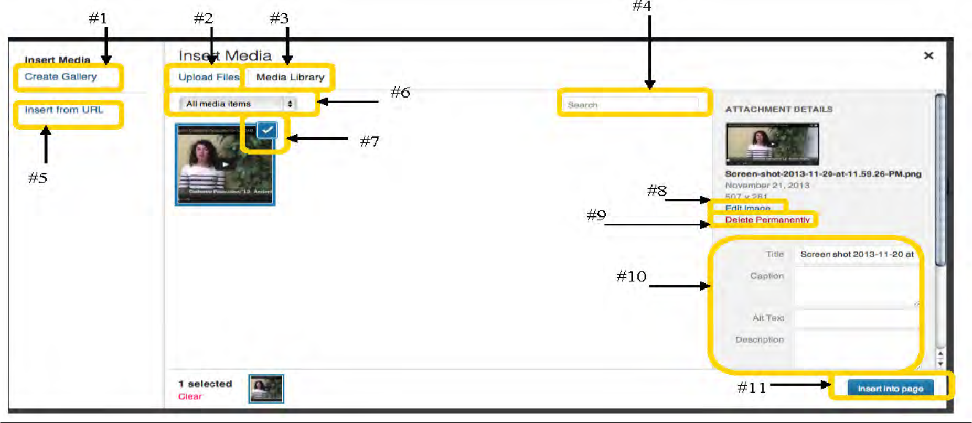
#1-Create Gallery: With the Create Gallery function you can make a gallery of images.
#2-Upload Files: If you don’t already have the media you want in your Media Library you can upload media by clicking Upload Files.
#3-Media Library: By clicking on this you can get back to the Media Library from the Upload page.
#4-Search Bar: You can type in a key word in the search bar in order to find the media item you are looking for.
#5-Insert from URL: By using this function you can insert an image from an exterior webpage.
#6-Media Sort Drop Down: By using this drop down you can short the files in your Media Library by the type of media they are.
#7-Selected Media: The blue square and check box indicate that you have selected that media item to be inserted on your page.
#8-Edit Image: By clicking on this you can edit your image before you put it onto your page.
#9-Delete Permanently: -WARNING - Clicking on this will delete this media item permanently from your Media Library.
#10-Media Details: This section is where you can change the title of the media item; or add a caption, alternative text, or description to the media item.
#11-Insert Media: Once you’re done you can insert your media into the page by clicking this button.

Embedding Media:
Media items from the following popular websites can be automatically embedded in your site:

  - YouTube
  - Vimeo
  - DailyMotion
  - Flickr
  - Photobucket

When editing the page on which you want media embedded, simply add the web address for the media item in the edit content area, ensuring it is on a line of its own and does not show up as a highlighted link.
For example:

Check out this cool video: http://www.youtube.com/watch?v=blahblah That was a cool video.

Embedding a Google Form:
- From your Google Drive, click the name of your desired Google Form to open the editor interface.
- In the toolbar at the top of the form, click 'File' and then select the 'Embed' option.
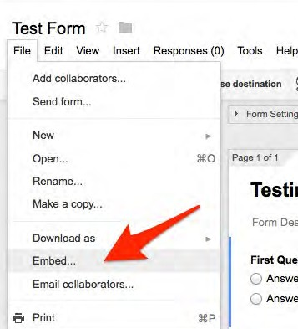
- Copy the text from the box that appears.
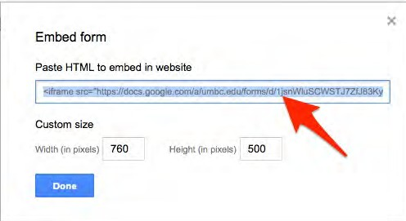
- Next, from the Site Dashboard of your sites.umbc.edu site, edit the page where you want the form to be shown.
- Switch to the 'Text' tab at the top of the editor and paste in the Embed text you copied from the Google Form page earlier.
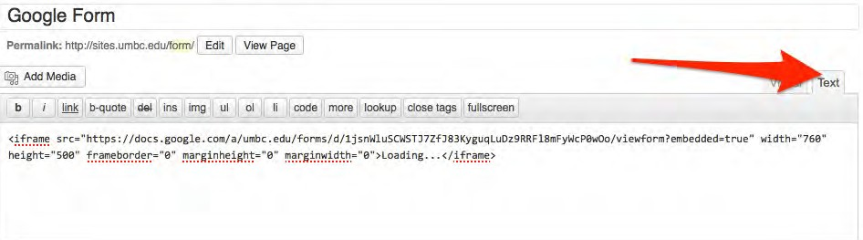

- Switch back to 'Visual' mode, and you will see a placeholder where your form will reside.
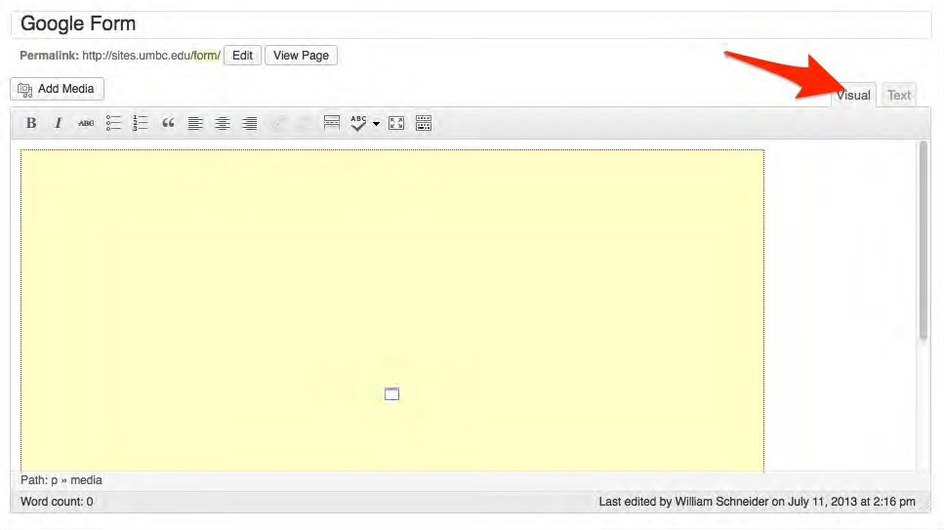
- Save the page, and you're done!

Embedding a Google Calendar:
Embedding a Google calendar is very similar to embedding a Google form.
  - Log into your Google calendar.
  - On the left hand side of the screen, select the drop down menu next to the calendar you would like to embed and go to “Calendar Settings.”
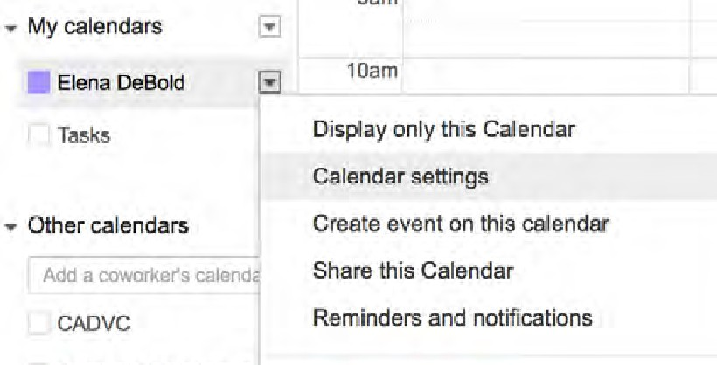
  - After selecting “Calendar settings” make sure you are in the “Calendar Details” tab, which can be found at the top left hand side of the page.
  - Once in the “Calendar Details,” scroll down to “Embed this Calendar.” At this point you can either embed the calendar as is (#2) or customize it further by clicking on the “Customize” link (#1).
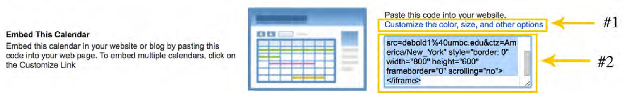
  - If you choose to customize the calendar make sure to use the embed code from the customization are.

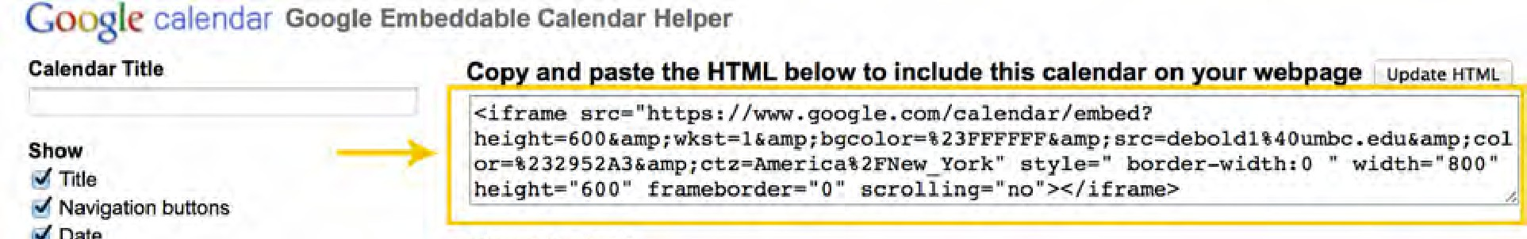
  - Copy the embed code.
  - Next, from the Site Dashboard of your sites.umbc.edu site, edit the page where you want the form to be shown.
  - Switch to the 'Text' tab at the top of the editor and paste in the Embed text you copied earlier.
  - Switch back to 'Visual' mode, and you will see a placeholder where your calendar will reside.
  - Save the page, and you're done!

Editing Image Format in the Text Box:
Tip: It is easiest to put an image above or below a block of text rather than beside it.
- Click on the image.
- Once you click on the image, a small menu appears. The first four icons allow you to align the image as well as adjust the wrapping of the text. The fifth icon (the small pencil) lets you further edit the image.
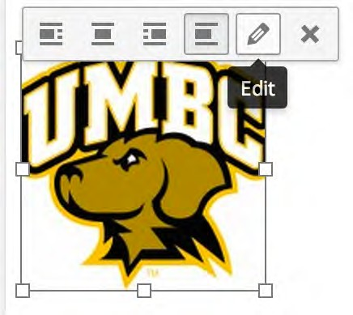
- Once you have clicked the pencil icon, the following page will pop up where you can edit the location, alignment, interaction with the text, the size of the image, and more.
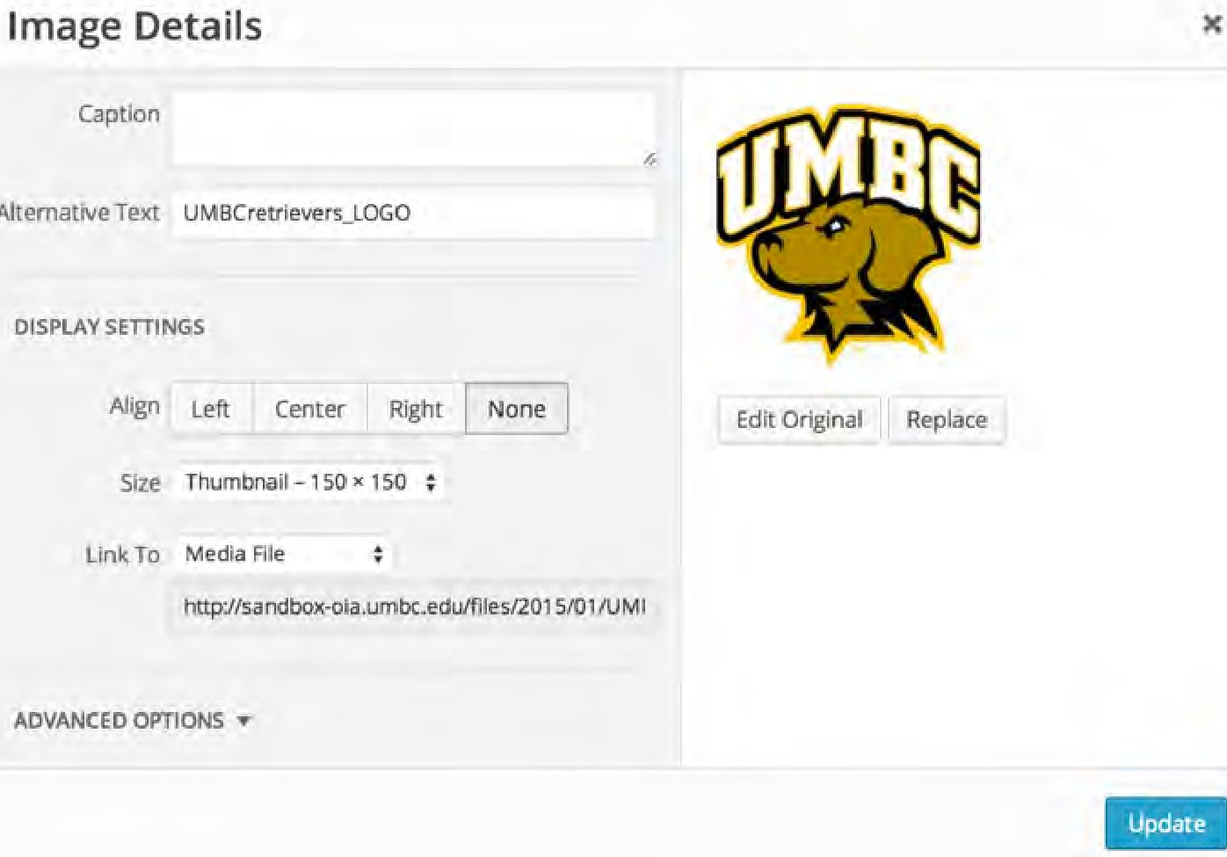

Making Buttons Using Images:
- Select the image and click on the small pencil icon.
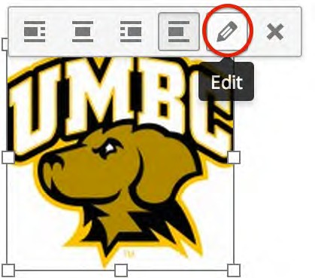
- Once you have clicked the pencil icon, select “Custom URL” from the “Link To” drop down menu. Then paste the URL you want the image to link to in the empty space below.
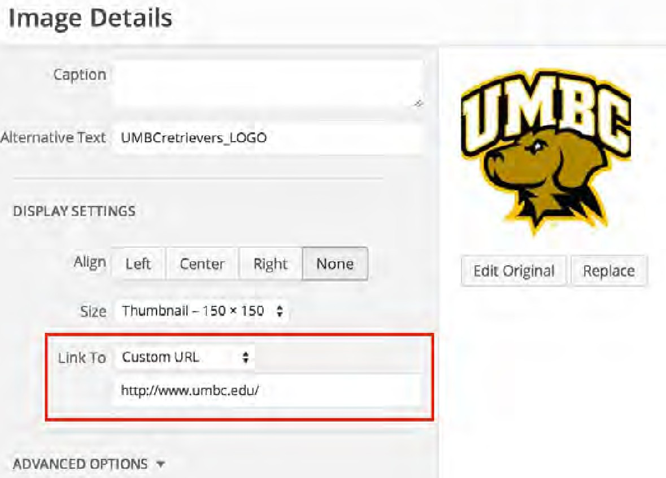
- To make sure the link opens in a new window, go to the “Advanced Options” section and check the “Open link in a new window/tab” box. Finally, make sure to click the “Update” button to save our changes.
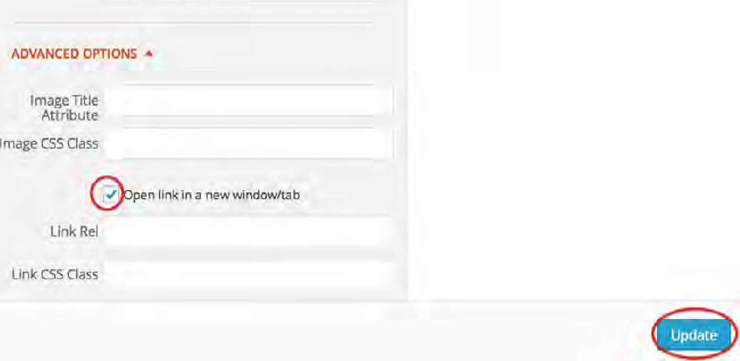

Slideshow:
How to add and manage slides:
  - From your Site Dashboard, click on the Slideshow link in the left-hand sidebar.
  - If you have already added slides to your slideshow, they will be shown on this page in the order that they are displayed in the slideshow widget.
3. When you hover over a slide, options to "Move Up" and "Move Down" appear. These change the order that slides are displayed in the slideshow widget.
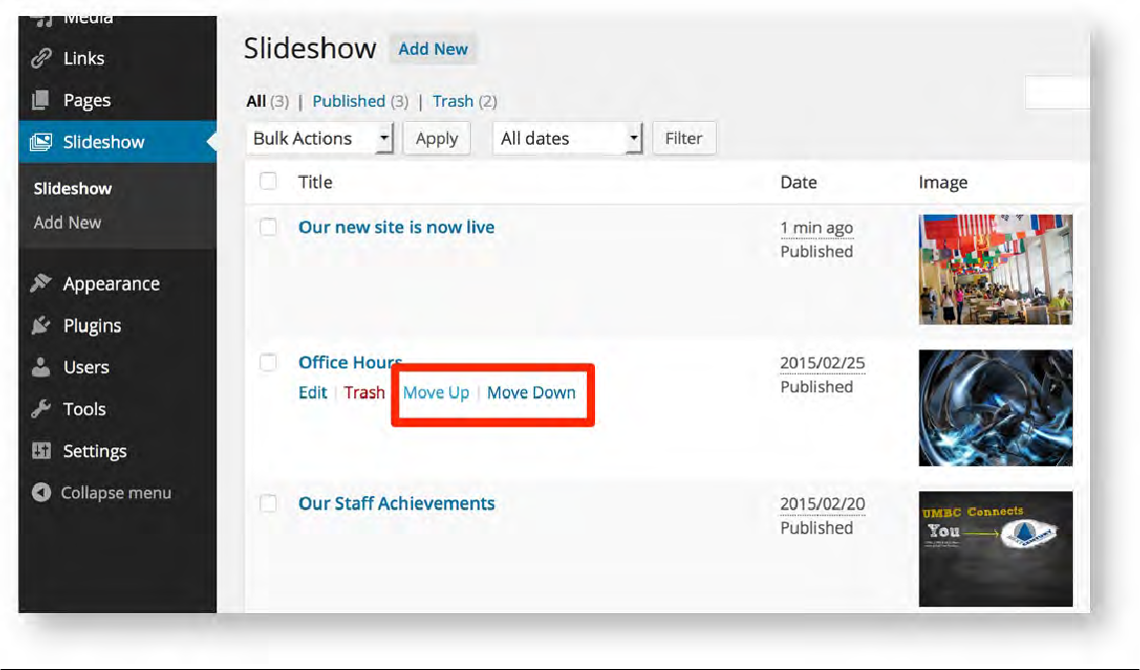
- From this page, you can also click Add New to add additional slides to your slideshow, or click Edit when hovering over a slide to edit it.
- When adding or editing a slide, enter a title, subtitle, URL to link to, and upload an image to use as the slide photo. Once you are finished, click "Publish" (or "Update" if you are editing an existing slide) to save your changes.

Important: When the slideshow is displayed, parts of the image may be cut off. Ensure your image is wider than it is tall, and that the important parts of your image are closer to the middle rather than at the edges. The ideal size for an image in the slideshow is 1024 x 768 pixels and the minimum size that can be used is 640 x 480 pixels.

How to add the Slideshow widget:
- Once familiar with how to add a widget to your site, add the Slideshow widget to a Widget Area (the "Home Page Main Section" is the one people generally use).
- Once added, the slides from your slideshow will be displayed on your site in the order shown on the Slideshow admin page.

Appearance:
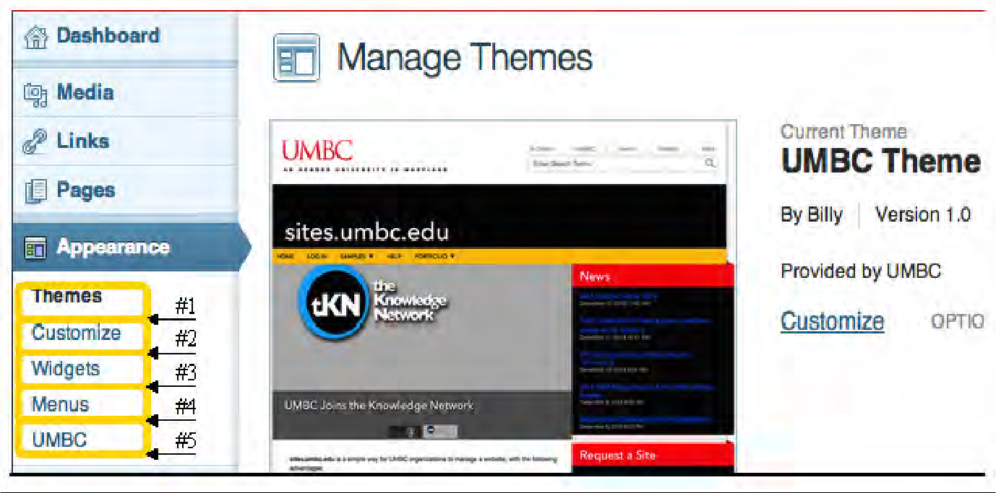
#1- Themes: Sites only has one theme called UMBC Theme. Therefore, this section does not act as it would in the regular WordPress and does not function in Sites.

#2- Customize: This provides an overview of the site while allowing you to change the site title/tagline as well as the front page being used (this functionality is also available elsewhere in the dashboard area).

#3- Widgets: Widgets provide a way for you to add independent sections of content to predefined areas on your pages (additional information on Widgets can be found on page 14).

#4- Menus: This is where you edit the page hierarchy and menus on your site (additional information on Menus can be found on page 16).

#5- UMBC: In this section you can edit the appearance of your site including adding a banner and changing the color pallet (additional information on the UMBC section can be found on page 19).

Widgets:
Widgets provide a way for you to add independent sections of content to predefined areas on your pages. These predefined areas are called "Widget Areas” and include sidebars as well as the top section of the Home Page template.

To get to the Widgets section:
- From your Site Dashboard, hover over the Appearance link in the left-hand sidebar and click the Widgets link.
- All of the available widgets are listed in the Available Widgets section. The "Widget Areas" are displayed down the right-hand side of the page in expandable boxes.
- To add widgets to your site, expand the "Widget Area" you wish use by clicking the gray triangle to toggle it open.
- Drag and drop the widget you want from the Available Widgets box to the "Widget Area" you just expanded.
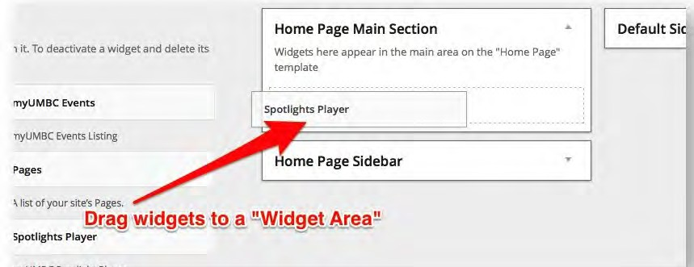
- You can also drag and drop widgets within or between "Widget Areas" to rearrange them.

Widget Areas: These are the places on your website where you can put widgets.

Home Page Main Section: located in the middle of your homepage.
Home Page Sidebar: located on the right of your homepage.
Default Sidebar: located on the left side every page of your website EXCEPT your homepage.

IMPORTANT NOTES:

  - The Home Page Main Section and Home Page Sidebar "Widget Areas" are only used on the page you have set to use the Home Page template. Similarly, the myUMBC News, myUMBC Events, and Spotlights Player widgets will only work if you have configured your site to use your myUMBC group.
  - The Spotlight Player widget can only go in the Home Page Main Section.

The Different Types of Widgets:
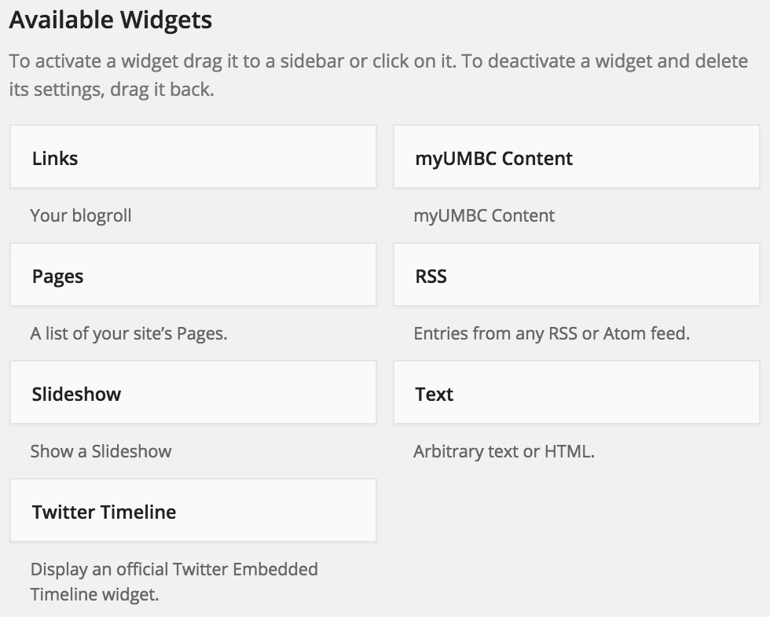
  - Links: Here you can put your blog roll or links to outside websites.
  - myUMBC Content: This widget pulls in the Posts, or Events from your myUMBC Groups page. You can choose how many items this widget displays and from which myUMBC Group the information is pulled. The "Group" dropdown includes myUMBC Groups your site has recently added. If the myUMBC Group you want to use is not in the list, select "Add New Group,” type in the myUMBC Group Token, then click "Add.” To find your group token go to page 15. Once a myUMBC Group is selected, pick the Section you wish to include content from. You can optionally specify tags, which filters the content shown to items containing at least one of the specified tags.
  - Pages: Here you can list quick links to pages within your site.
  - RSS: You can also put in your blogroll here as well as RSS feeds from other sites.
  - Slideshow: This displays slide show you create in Slideshow section. For more info go to page 20.
  - Text: In this widget, you can put in normal text, URLS, or HTML code.
  - Twitter Timeline: This displays your twitter timeline.

IMPORTANT: You can dedicate an entire page to your myUMBC Posts and Events, which will automatically update the content whenever you update those sections of the myUMBC group. If you also want widgets that pull in myUMBC group content, they will automatically link to your myUMBC group pages on your Sites page rather than back to your myUMBC group page. Thus we strongly recommend creating matching myUMBC groups pages if you have myUMBC groups content being pulled into widgets. To learn how to create Sites pages incorporating myUMBC Groups content go to page 12.

Menu:
- From your Site Dashboard, hover over the Appearance link in the left-hand sidebar and click the Menus link.
- Find the Pages options box. In this box, the available pages in your site are listed.
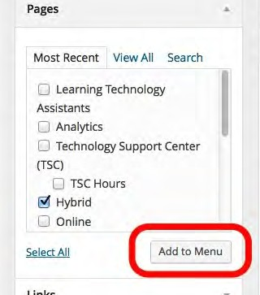
- Place checks in the boxes next to pages you want to add to your navigation menu, and click “Add to Menu.” This adds them in the main area at the right of the screen.
- Drag and drop menu items to create the navigation structure you desire.
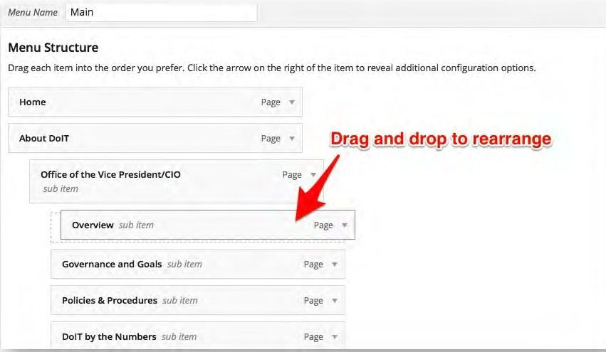
- Once you are happy with the way your menu is structured, click the blue “Save Menu” button at the top right-hand side of the page.

Creating A Menu Item That Is A Link:
- Go to the “Menus” area of the Dashboard under “Appearance.”
- Once in the “Menus” area find the section to the left of the screen that says “Links” and click on the drop down arrow next to “Links.”
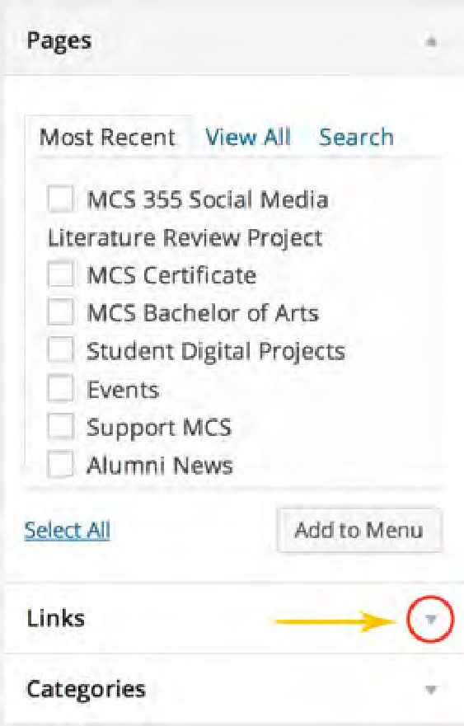
- Once in the “Links” drop down menu insert the URL (#1) and then put what you want the menu item to be named in the “Link Text” area (#2). Then click the “Add to Menu” button (#3).
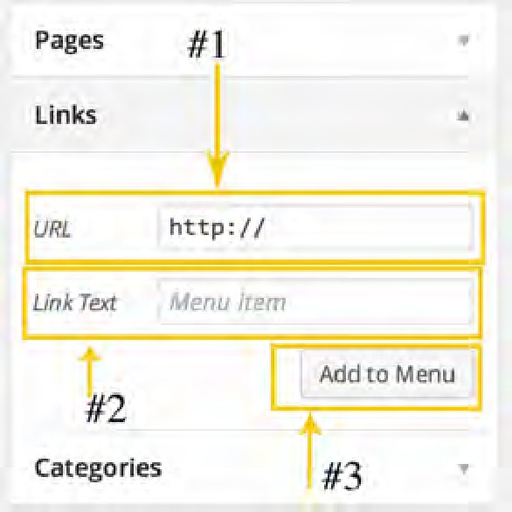
- Now the menu item will appear on the hierarchical menu diagram to the right of the screen. Just like a normal menu item, place the link menu item where you would like it to go in the menu hierarchy and press the “Save Menu” button.

Making Un-clickable Menu Items:
Normally the items on the menu bar are clickable and have pages of their own as shown below:



However, the menu bar does not have to be clickable and can only work as a header for a drop down. An example of this is the Linehan Artist Scholars Program site (http://linehan.umbc.edu). The “Scholars Experience” menu is not clickable (so it does not need its own page) and only works as a drop down menu.

- The first step in doing this is to figure out where it is appropriate to use this method of drop downs. Un- clickable menu buttons can be used for the following cases:
  - You want to use a menu button as a drop down heading.
  - The menu bar button does not need its own page.
- Once you have decided that it is appropriate to use this method, go to the Dashboard on your Sites page and click on “Appearance” and then “Menus.”
- Find the “Custom Links” area as shown below:
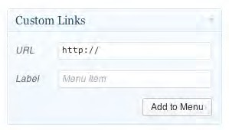
- For the URL type in a # sign. The # sign is equivalent to a blank space and will not show up on your menu.
- Then fill in what you want that menu bar button to be titled. Here is an example of what the “Custom Links” area looks like filled out:
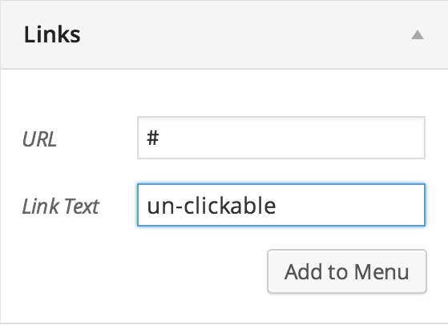
- Then click the “Add to Menu” button.
- This new menu button should show up as a menu item at the bottom of the list in the hierarchical menu diagram. Move the menu item where you would like it to show up in the menu.
- Now click “Save Menu” in the upper right hand corner of the page.

Appearance: UMBC:

How to Add a Banner: A site banner can be a good way to add a colorful image or branding to your site.
- From your Site Dashboard hover over the “Appearance” link in the left-hand sidebar and click the “UMBC” link.
- Click in the box labeled “Header Image” and select the image you wish to use (note that it should be 960 pixels wide and 130 pixels tall).
  - If you do not want to show the default site name text in the header area, uncheck the box labeled “Show Text in Header.”
  - If you have a separate image you wish to use for your site header on mobile devices, use the box labeled “Mobile Header Image” to select an image 368 pixels wide and 48 pixels tall, and use the “Show Text in Mobile Header” to toggle the default site name text on or off

- At the bottom of the page, click “Save Changes” to save your new banner.

How to Add Page Footers:
- From your Site Dashboard hover over the “Appearance” link in the left-hand sidebar and click the “UMBC” link.
- Click in the box labeled “Page Footer.” You only need to fill in as many sections as you need. Colors of the footers are chosen automatically depending on the color pallet that you have chosen.
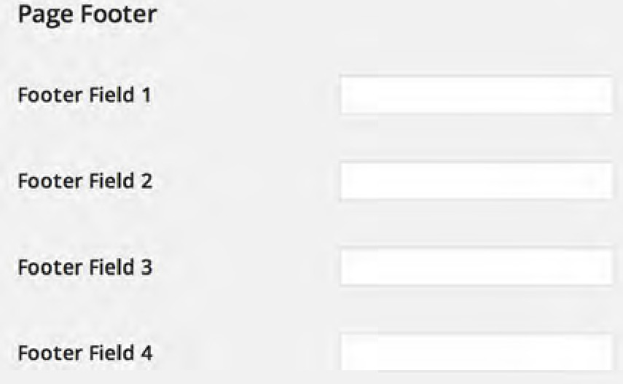

How to Change the Sites Color Palette:
There are two ways to change your Sites color palette:
- You can choose from the pre-set color palette.
- Or you can choose your own colors in the “Custom Color” section.

Custom Color:
- Custom Colors are an advanced option.
- There are 20 different custom color fields, providing a large amount of flexibility to customize the colors of your site.
- You can select a color from the color wheel or use a HEX number.

- From your Site Dashboard hover over the “Appearance” link in the left-hand sidebar and click the “UMBC” link.
- In the section with the “Colors” heading and choose “Custom Colors.”
- Be sure to click the “Save Changes” button at the bottom of the page once you are finished.

You can use the following key to help you pick colors:
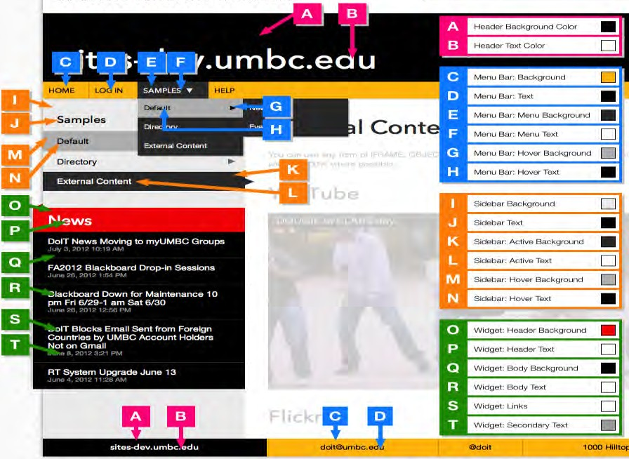

General Settings:

How to Use a Google Analytics Account with Sites:
In order to have a Google Analytics web tracking ID you must first set up a Google Analytics account. Once you have set up an account you may follow the steps below in order to add Google Analytics tracking to your Sites page.
- Find the Web Tracking ID for the Google Analytics account you wish to use (it should be something like "UA-123456-78").
  - Refer to this Google article (https://support.google.com/analytics/answer/1032385?hl=en) to learn how to find your Web Tracking ID.
- Next, from your Site Dashboard hover over the “Appearance” link in the left-hand sidebar and click the UMBC link.
- Enter your Google Analytics Web Tracking ID (from step 1) into the text box labeled Google Analytics web tracking ID and click “Save Change.”

*IMPORTANT: After editing anything in the UMBC Appearance are you MUST CLICK THE SAVE CHANGES BUTTON at the bottom of the page for your changes and edits to be saved. *

Users:
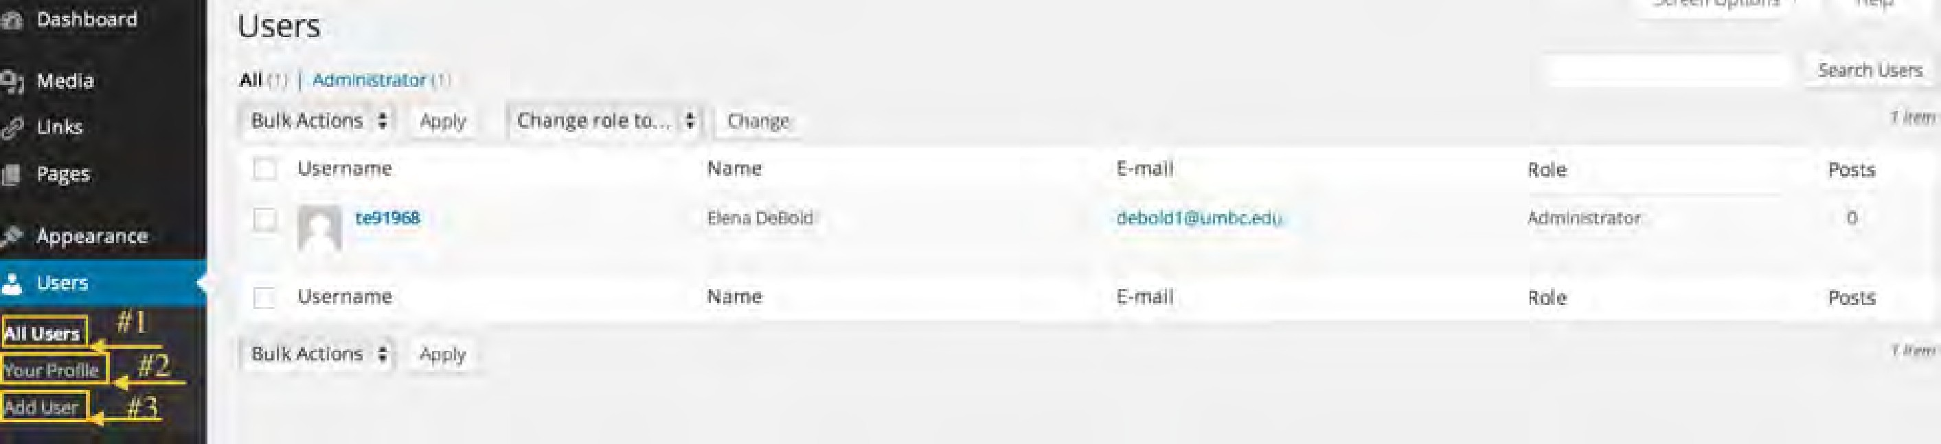
When you click on “Users” on the sidebar menu, the following page will appear:
#1: All Users: This is where you can see all of the “Users” (meaning people who can edit the site). In this section you can do bulk delete to delete multiple users at one time. Deleting a user revokes their access to edit the site. Here you can also see how many posts the user has completed as well as their email and role. Note: All users should have the Administrator as their Role in order to edit the site.
#2: Your Profile: Here is where you can set your personal options and edit your profile information.
#3: Add User: In this section you can add users so that they can edit the site.

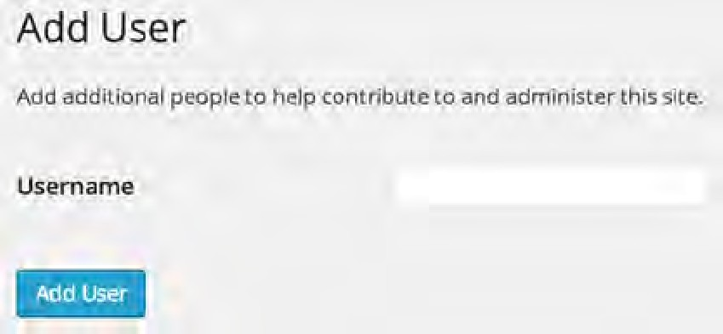
Adding a User: When you click on Add User the following page will appear:

In order to add a user all you have to do is type in the person’s UMBC username or campus ID into the box and click the Add User button. Note: for the UMBC username you only need the username part not the @umbc.edu portion.

Removing a User:
- From your site’s dashboard, click the Users link in the left-hand sidebar.
- Find the person you wish to remove from the list.
- Hover over the Campus ID of the user.
- Click the Remove button, which appears below their Campus ID.
- Click the gray Confirm Removal button if you are sure you still wish to remove this person.

Settings: The Settings area is where you can adjust some settings of the sites page. However, most settings are on default and do not need to be altered. Unless you are more proficient with Wordpress or Sites, please do not change any settings. If you believe that settings should be changed please contact UMBC’s Division of Information Technologies.

myUMBC Groups Page:
Each Sites website can have a myUMBC Groups page. A myUMBC groups page is where you can create and edit Posts and Events, which also can feed to your Sites page. In addition to using the myUMBC Groups page in conjunction with Sites, it is also a great way for departments, clubs, and committees to have their own corner of the UMBC web to connect and collaborate. Groups has been designed to be simple and straightforward to use, but still offer enough flexibility to meet the needs of our diverse campus.
Notes:
- Each group gets their own myUMBC web address: my.umbc.edu/groups/groupname.
- Groups get their own copy of the myUMBC community tools: Posts, Events, Files, and Promotions.
- Customize your group with a custom banner and avatar.
- Make your group as public or private as you want. You can configure which tabs people see, who can join your group, and what different types of members can do.

- Easily share content created within your group with the entire UMBC community.
- Subscribe your group to content from other groups or from external sites via RSS, YouTube, Vimeo, and Flickr.
How to Create a myUMBC Groups page:
  - Log on to myUMBC with your normal UMBC log in and password.
  - Click on “Groups” in the menu bar at the top of the homepage.
  - On the drop down menu select the section title “Start a Group.”
  - You will now be directed to a form. Fill out the form and press “Request Group.”
IMPORTANT: You CANNOT CHANGE the “Access” setting of the group once the group has been created.

Getting Started on your myUMBC Groups page:
- Once your myUMBC group has been created log on to myUMBC and you should see the title of your group under “Your Groups.” You may have multiple groups depending on how many you have requested or you are apart of.
- Click on the group you want to edit or update.

myUMBC Posts and Events on Sites Pages:

You can dedicate an entire page to your myUMBC Events or Posts, which will automatically update the content whenever you update those sections of the myUMBC group. If you also want widgets that pull in myUMBC group content, they will automatically link to your myUMBC group pages on your Sites page rather than back to your myUMBC group page. Thus we strongly recommend creating matching myUMBC groups pages if you have myUMBC groups content being pulled into widgets. To learn how to create Sites pages incorporating myUMBC Groups content go to page 12. To learn how to create widgets incorporating myUMBC Groups content go to page 22.

myUMBC Group News:
- Once inside your myUMBC Groups page, select the “News” tab.
- Then click on the “Post Story Button” on the right hand side of the page.
- The following page will appear:
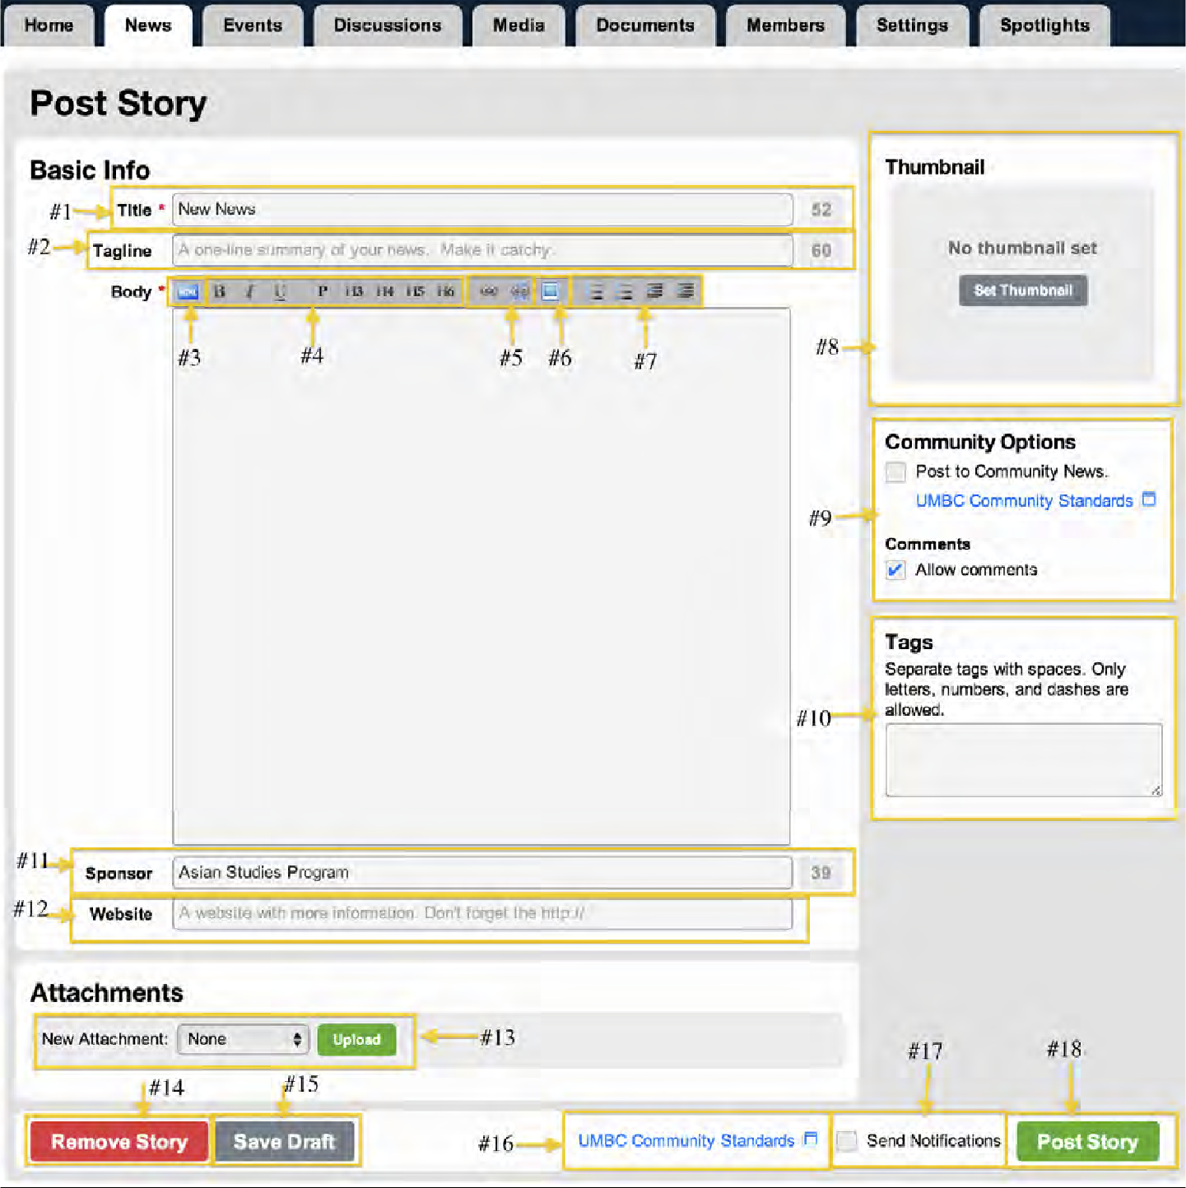
#1 - Title: Here is where you put the title of your News post. The title is limited to 60 characters and is a mandatory requirement when posting a news story.
#2 - Tagline: Tag lines are not mandatory for posting a news story but they are helpful to draw an audience to the story and will assist the audience in searching for the story. This too is limited to 60 characters.
#3 - HTML Button: Pressing this HTML button will show you the HTML code behind all of the formatting and text in the text box. We ask that you do not edit the HTML unless you are proficient at HTML coding.
#4 - Formatting Tools: This is the text box menu bar where you can set the formatting of your news post. These menu items are similar to most word processing applications and provide most of the same functions.
#5 - Hyperlink Button: These two buttons are used to hyperlink and un-hyperlink text that you select
#6 - Embed Image Tool: This button lets you embed images from a URL.

#7 - Alignment and Lists Tools: Like most word processing applications, these buttons are used for alignment and making lists.
#8 - Thumbnail Tool: The Set Thumbnail tool lets you select an image from your computer or a library of UMBC stock photos to be associated with that News story (see page 31 for more information on images and the Thumbnail tool).
#9 - Community Options: This section is where you can request that your news story be posted on the main myUMBC page. There is also a link to UMBC Community Standards and a check box where you can allow or restrict your audience to comment on the news story.
#10 - Tags: You can add tags to your news story in order to make it easier to search for.
#11 - Sponsors: In this section you can note other organizations or departments that assisted with the subject of the news story. For instance if you held an event and other departments assisted, you may also want to acknowledge their work.
Your department’s name will automatically show up in this area but can be erased. Keep in mind you only can use up to
60 characters in this area.
#12 - Website: Here is where you can put a link to more information about the news story or a link that is related to the news story.
#13 - Attachments: In this section you can select a document (document, flyer, etc.) to be attached to the news story.
#14 - Remove Story: If you would like to delete the news story you can press the Remove Story button. WARNING: this will permanently delete your news story.
#15 - Save Draft: The save draft button allows you to save a draft of your news story without publishing it.
#16 - Community Standards: This is another link to Community Standards.
#17 - Send Notifications: Checking this box will send a message to all the members of your myUMBC groups page stating that you posted a new news story.
#18 - Post Story: Once your news story is ready to be posted hit the Post Story button.

myUMBC Group Events:
- Once inside your myUMBC Groups page, select the Events tab.
- Then click on the “Post Event” on the right hand side of the page.
- The following page will appear:
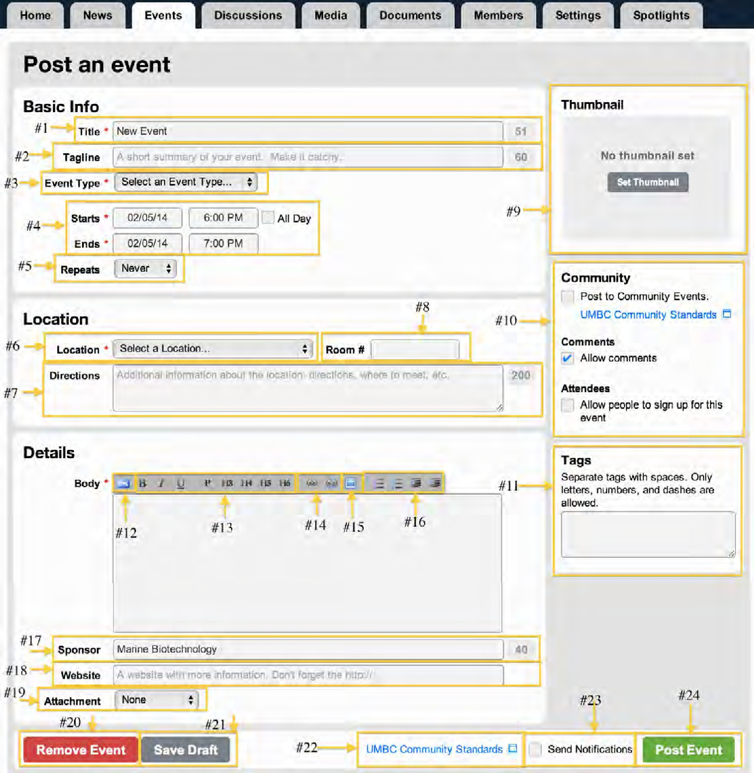
#1 - Title: Here is where you put the title of your Event. The title is limited to 60 characters and is a mandatory requirement when posting an Event.
#2 - Tagline: Tag lines are not mandatory for posting a Event but they are helpful to draw an audience to the story and will assist the audience in searching for the story. Also limited to 60 characters.
#3 - Event Type: Using this drop down menu you can note what type of event you are holding. There are more general event types that can be selected if none of the other types describes your event.
#4 - Start and End Date/Time: In these boxes is where you will put the date and time your event begins and ends. You can also check the “All Day” box.
#5 - Repeats: If your event repeats you can use this drop down to repeat the event posting daily, weekly or monthly.

#6 - Location: In this drop down you can choose the location of your event. If the specific location of the event is not on this drop down you can choose the general selection “On Campus” or “Off Campus” and then type more specific information in the “Room #” box.
#7 - Directions: You can put directions into this area but you must stay under 200 characters.
#8 - Room #: The “Room #” area can be used for the room number or other specific location information.
#9 - Thumbnail Tool: The Set Thumbnail tool lets you select an image from your computer or a library of UMBC stock photos to be associated with that Event (see page 31 for more information on images and the Thumbnail tool).
#10 - Community Options: This section is where you can request that your Event be posted on the main myUMBC page. There is also a link to UMBC Community Standards and a check box where you can allow or restrict your audience to comment on the Event. In addition, under Attendees, you can select whether or not your audience members can sign up to come to this event. This is especially helpful when seating is limited.
#11 - Tags: You can add tags to your Event in order to make it easier to search for.
#12 - HTML Button: Pressing this HTML button will show you the HTML code behind all of the formatting and text in the text box. We ask that you do not edit the HTML unless you are proficient at HTML coding.
#13 - Formatting Tools: This is the text box menu bar where you can set the formatting of your news post. These menu items are similar to most word processing applications and provide most of the same functions.
#14 - Hyperlink Button: These two buttons are used to hyperlink and un-hyperlink text that you select.
#15 - Embed Image Tool: This button lets you embed images from a URL.
#16 - Alignment and Lists Tools: Like most word processing applications, these buttons are used for alignment and making lists.
#17 - Sponsors: In this section you can note other organizations or departments that assisted with the subject of the news story. For instance if you held an event and other departments assisted, you may also want to acknowledge their work.
Your department’s name will automatically show up in this area but can be erased. Keep in mind, you only can use up to 60 characters in this area.
#18 - Website: Here is where you can put a link to more information about the Event or a link that is related to the Event.
#19 - Attachments: In this section you can select a document (document, flyer, etc.) to be attached to the Event.
#20 - Remove Story: If you would like to delete the Event you can press the Remove Event button. WARNING: this will permanently delete your Event.
#21 - Save Draft: The save draft button allows you to save a draft of your Event without publishing it.
#22 - Community Standards: This is another link to Community Standards.
#23 - Send Notifications: Checking this box will send a message to all the members of your myUMBC groups page stating that you posted a new Event.
#24- Post Event: Once your Event is ready to be posted hit the Post Story button.

Setting a Thumbnail for your Event, News, or Spotlight:
- Click the “Set Thumbnail” button in the upper right hand corner under “Thumbnail.”
- Once you click that button the following window will appear:
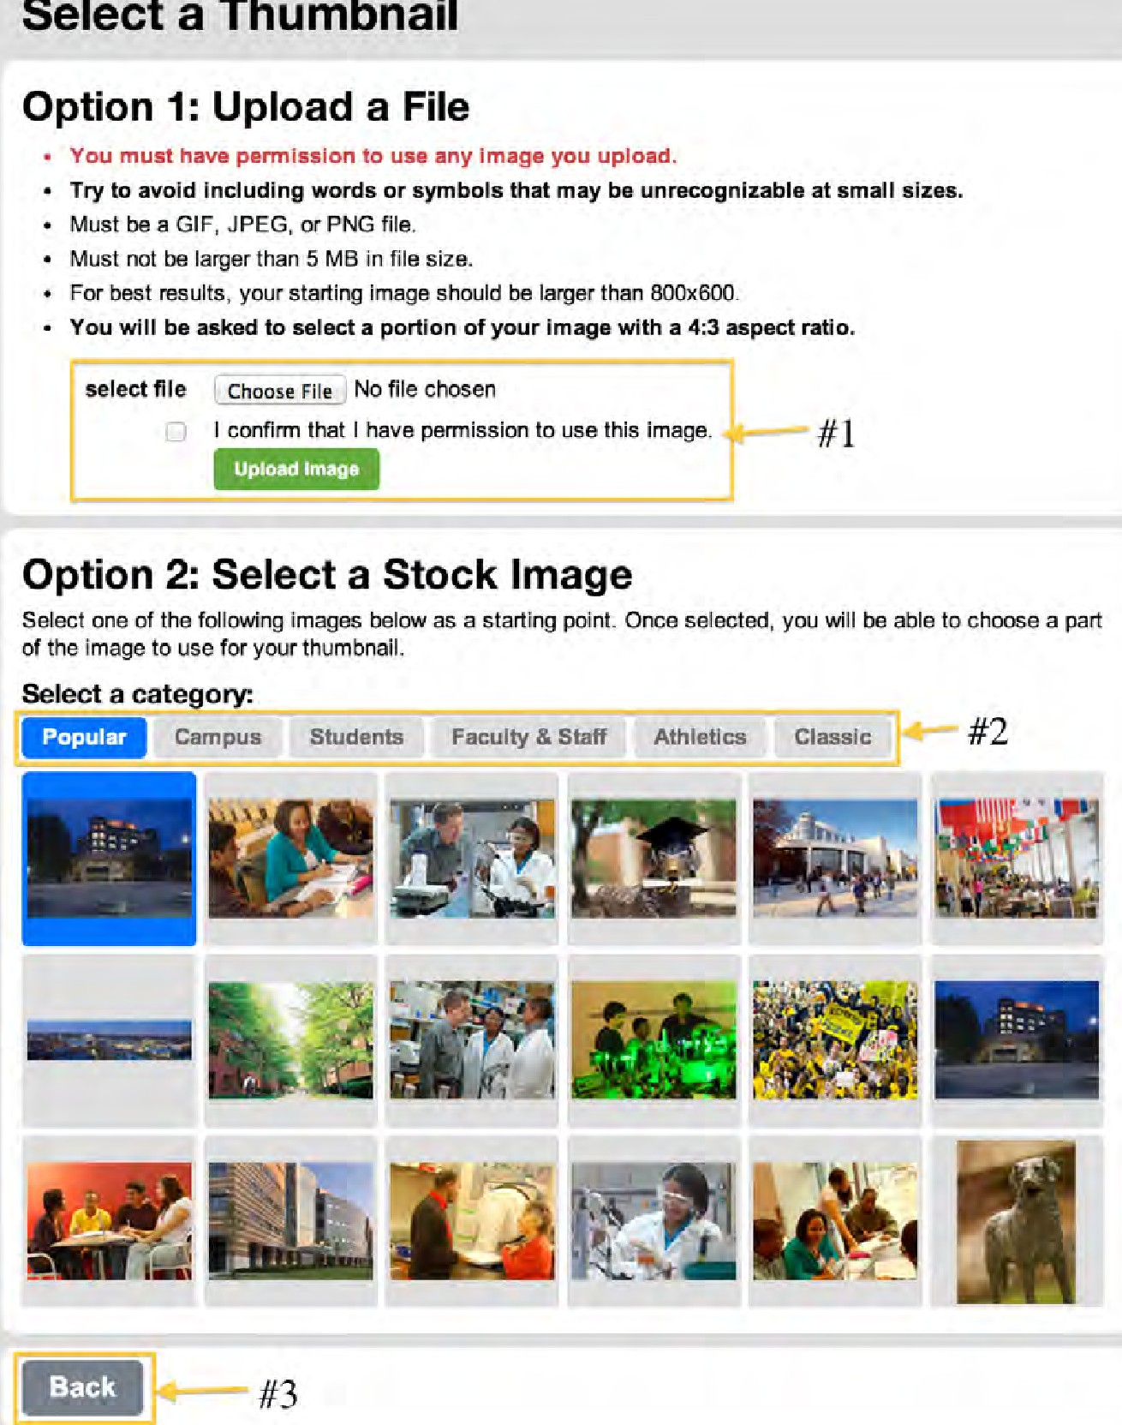
#1 Select file: With “select file” you can select an image form your computer for your thumbnails or spotlights.
#2 Stock Image Categories: If you do not want to use an image from your hard drive you can select an image from the stock images. Use these tabs to navigate through the different categories.
#3 Back: If you decide to return to your myUMBC group just click the “Back” button.

After Selecting an Image:
  - After selecting an image you will be redirected to the cropping tool (shown below). Here is where you will select which part of the image you would like for your thumbnail. Keep in mind that this cropping tool only crops to a certain ratio. Also, sometimes the crop tool is not accurate in showing how much of
the image is actually cropped so you may need to try cropping the image a couple times before getting the correct cropping you want.
  - To crop the image, drag one of the corners or mid sections shown circled in red in the image below.
  - Once you are done cropping you can either click the “Select Another Image” button to select a different image or click the “Crop Thumbnail” button once you are satisfied with the cropped image.
  - If the thumbnail is still not satisfactory you may go back and crop the image again.
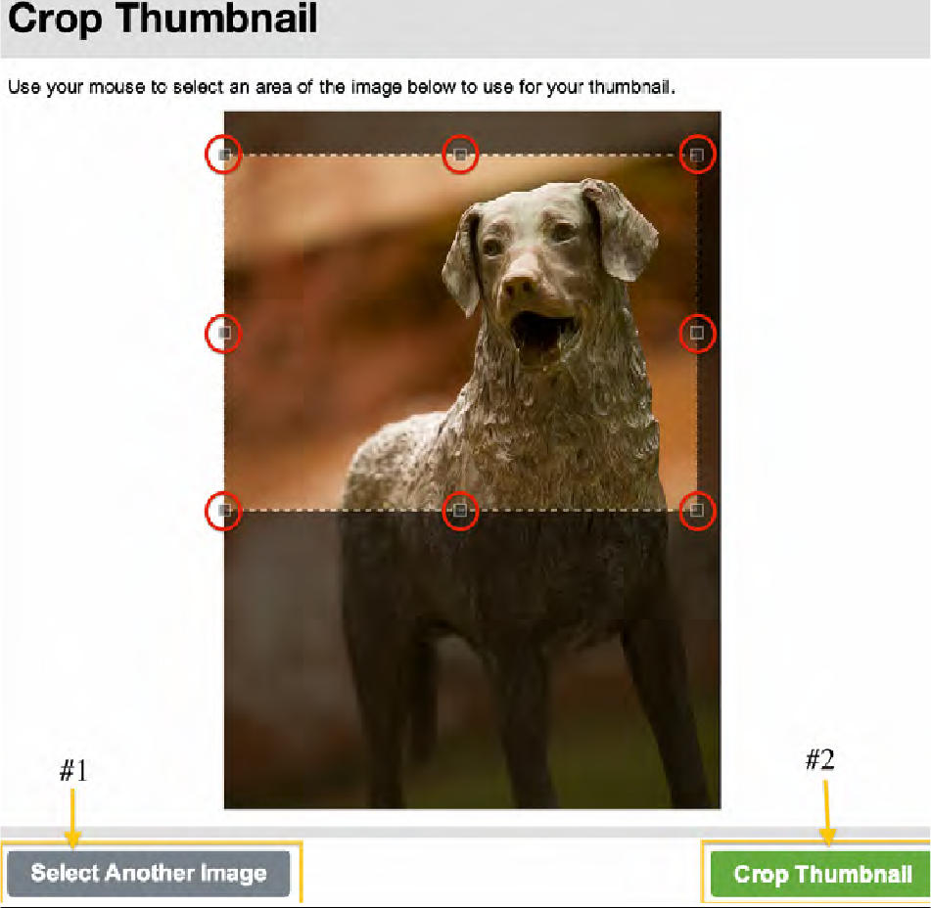

Cropping:
#1 Select another Image: Click here to select another image either form your computer or from the stock photos.
#2 Crop Thumbnail: Once you have cropped your image the way that you want it click the “Crop Thumbnail” button.



: Use these squares to crop the image.
After you’ve completed your training and set up your Sites page, remember to log into http://my.umbc.edu/groups/sites to join your user group community to find other site users on campus.
Your sites user groups are a great way to ask other Sites members question, share comments and have discussions, and receive the latest updates in Sites news.

*After you complete your training and set up your Sites page, remember to log into http://my.umbc.edu/groups/sites to join your Sites User Group community to find other sites users on campus.
Sites User Groups are a great way to ask other Sites members questions, share comments, and receive the latest updates in Sites news.*

