NIGMS Director’s Early-Career Investigator Lecture

Sex-Biased Genome Evolution


Melissa A. Wilson, Ph.D.

Arizona State University

Wednesday, April 10, 2019
10:00-11:30 a.m. ET

Lister Hill Auditorium (Building 38A)
National Institutes of Health
Bethesda, Maryland

Lecture followed by Q&A session

Videocast live and archived at
https://videocast.nih.gov
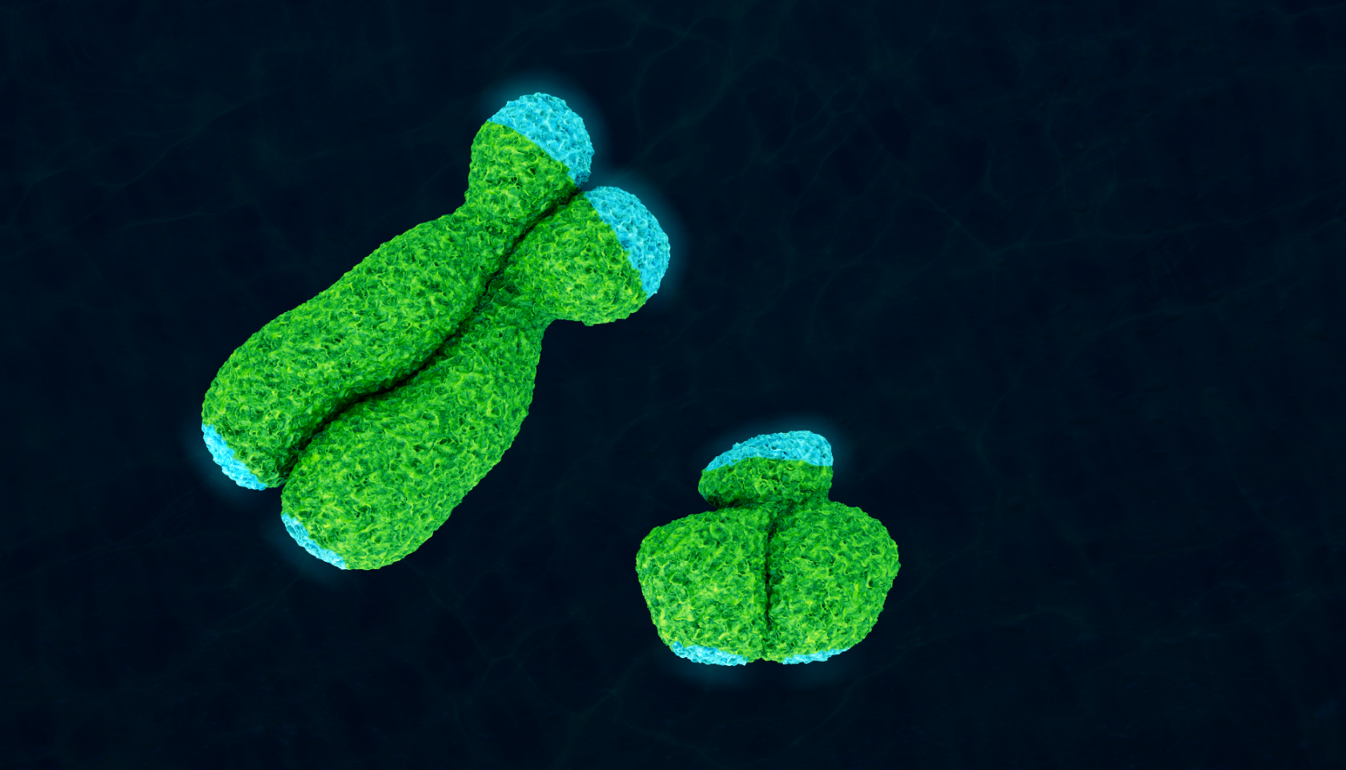

Assistant Professor of Genomics, Evolution, and Bioinformatics

Assistant Professor in the Center for Evolution and Medicine,

The Biodesign Institute

Arizona State University

Research summary, biosketch, and lecture information at

https://www.nigms.nih.gov/ECI/2019

