
Community Wellness Day  Join us for a full day of activities to support wellness and wellbeing | 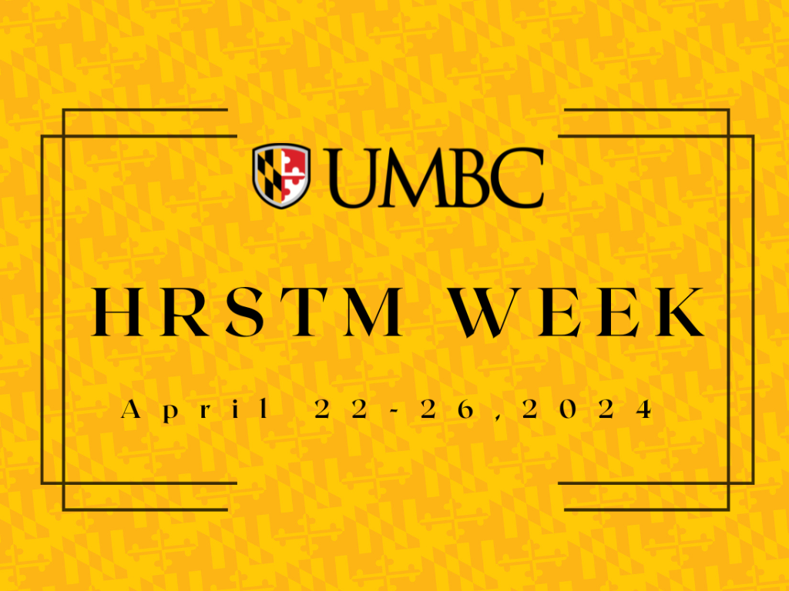

Tuesday, April 23, 2024
Time | Session | Location | Description
7:15-8:05am | Yoga | RAC 144 | https://recreation.umbc.edu/fitness-wellness/class-schedule/class-descriptions/
9:00-10:00 am | Community Mindfulness For Mental Health | Virtual | Take a brain break and join in a community mindfulness practice with other members of our faculty and staff population.
10:00-11:00 am | Seated Chair Massage | RAC Room 144 | 15 minute slots offered on a first-come first-served basis. Come by the RAC lobby desk to sign up and claim your spot.
11:00am-  12:00 pm | Seated Chair Massage | RAC Room 144 | 15 minute slots offered on a first-come first-served basis. Come by the RAC lobby desk to sign up and claim your spot.
12:00-  1:00pm | Mason Jar Salad Make + Take | RAC Room 106 | Join UMBC Nutritionist, Adam Sachs, for a first-come, first-served DIY wellness lunch.
12:15-  12:45 pm | Basic Strength | RAC 144 | https://recreation.umbc.edu/fitness-wellness/class-schedule/class-descriptions/
1:00-2:00pm | Stress-A Way of Life or a Fact of Life? | Virtual | Stress affects everybody, but the effects don’t have to be damaging. In this EAP webinar learn coping techniques that will help you harness the positive effects of stress without the negative consequences.
2:00-3:00pm | Acupuncture | RAC Room 144 | 15 minute slots offered on a first-come first-served basis. Come by the RAC lobby desk to sign up and claim your spot!
5:00-6:00pm | Vinyasa Yoga | RAC 144 | https://recreation.umbc.edu/fitness-wellness/class-schedule/class-descriptions/
6:00-7:00pm | Zumba | RAC 144 | https://recreation.umbc.edu/fitness-wellness/class-schedule/class-descriptions/
7:00-8:00pm | Barre | RAC 144 | https://recreation.umbc.edu/fitness-wellness/class-schedule/class-descriptions/
8:00-8:30pm | Cycle | RAC 124 | https://recreation.umbc.edu/fitness-wellness/class-schedule/class-descriptions/

